INSTRUCTIONS TO PREPARE A PAPER

First A. Author¹, Second B. Author² and Third C. Author³
^{1,2} University of Zagreb Faculty of Civil Engineering, Department of Materials
Fra Andrije Kacica Miosica 26, 10 000 Zagreb, Croatia
e-mail: abaricevic@grad.hr, dubravka@grad.hr

³ University of Zagreb Faculty of Textille Technology, Department of Materials, Fibres and Textile Testing
Prilaz baruna Filipovića 28a, 10000 Zagreb, Croatia
e-mail: coms@grad.hr
SUMMARY: Use 10pt Arial Regular. The word SUMMARY must be set in uppercase, at the beginning of the first line. A 30pt space should separate the summary from the affiliations. The text should be justified and separated 12pt from the keywords. Abstract should not be longer than 300 words.
KEY WORDS: List 4-6 keywords. This paragraph also uses the 'Summary' style.

INTRODUCTION
This document provides information and instructions for preparing the full-length Paper (8 pages at maximum) for the 1st International Conference on Construction Materials for Sustainable Future. It should contain and be structured in the following way: introduction (problem statements, application area, research course), method used, results, conclusion and references. The Authors should prepare a Paper according to the instructions and submit electronically via web page www.grad.hr/coms before December 15th, 2016.

GENERAL SPECIFICATIONS
The Paper must be written in English, within a printing box of 20.5cm x 29.2cm, centred in the page. The margin settings are all equal at 0.5 cm on Left, Right, Top and Bottom of the page. The main body of the text is in Arial 10 pt, 1.15 line spacing and justified. The paper is restricted to exactly eight (8) A4 pages. Use 10 pt font for tables, figure captions and the references.

TITLE, AUTHORS, AFFILIATION, Text, Figures and tables
The first page must contain the Title, Author(s), Affiliation(s), Summary and Keywords. Type the correct affiliation (Name of the institute, City, State/Province, Country). The Introduction must begin immediately below, following the format of this template.

Title, Author, Affiliation
The title should be written left, in 18pt, Arial Regular, all uppercase letters. It should be single spaced if the title is more than one line long. The author's name should include first name, middle initial and surname. It should be written left, in 12pt Arial Regular, 12pt below the title. Author's affiliation should be written left, in 10pt Arial Regular, 6pt below the list of authors. A 10pt space should separate two different affiliations.

Text, Figures and tables
The normal text should be written 1.15 spaced, justified, using 10pt Arial in one column. The first line of each paragraph must be indented 0.5cm.
Figures, i.e. illustrations and pictures should be set into the body of the text at appropriate point, close to where they are referenced in the text and not grouped together at the end of the paper. Place the pictures between paragraphs and centre them between the margins. Figures layout should be in line with text. Always use the Figure caption style tag (9 points size, centred). Place the caption underneath the figure. Caption of a picture should use “Figure” style. A 12 point line space should separate the figure caption and the text of the paper, and a 12pt space should separate the upper part of the figure from the surrounding text. Figures should be included in the text of the Paper. Figures and photographs should have a resolution of 600 dpi and will be produced in colour in the book.
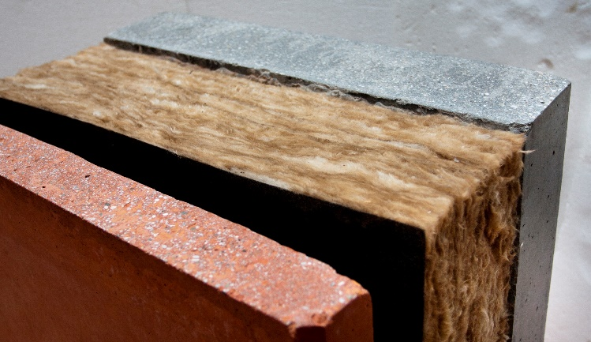

Figure 1: Figure caption
Locate tables close to the first reference to them in the text and number them consecutively. Place the caption above the table. Caption of a table should use “Table” style. A 12 pt line space should separate the table caption and the text of the paper, and a 12pt space should separate the lower part of the table from the surrounding text. Use “Table style” for table formatting.

Table 1: Styles in use in the preparation of this document
Style name | Typeface | Size | Alignment | Line spacing

Referencing Convention
References should be indicated on the text by a sequence number in square brackets [1]. They should be numbered in the order in which they appear in the text. The reference should give the authors names – each followed by their initials, and then the title of the paper, the name of the journal or conference in which it was published, the volume number (if applicable) and the year of publication and page numbers. All references should be complete so that they can be found by anyone wishing to follow them up. ISBN/ISSN numbers should be provided where they have been allocated. For books the place of publication is also required. The conference list at the end of this specimen paper contains examples of the referencing of variety of journal, conference, book and other references the style of which should be followed in preparing your paper.

CONCLUSIONS
Please don’t forget that the full-length Paper should be submitted electronically via web page www.grad.hr/coms before December 15th, 2016.

ACKNOWLEDGMENTS
This optional heading should be inserted just before ‘References’ heading. Both headings (ACKNOWLEDGEMENTS and REFERENCES) should be in bold 12pt, Arial Regular, all uppercase letters, without numbering. Acknowledgments text should be in 10pt, Arial Regular.

References

- Surname, N.; Surname, N.: Name of Book (in Italics), Publisher, ISBN, Place of Publication, (YYYY)
- Surname, N. & Surname, N.: Name of paper or Chapter, In Name of Book (in Italics), Publisher, ISBN, Place of Publication, (YYYY), pp. xxx-yyy
- Surname, N.; Surname, N. & Surname, N.: Title of conference paper, Proceedings of xxx xxx, Surname, N. (Ed.), pp. xxx-yyy, ISBN, conference location, Month and Year, Publisher, City, (YYYY)
- Surname, N.: Name of paper, Name of Journal (in Italics), Vol. (YYYY) No., pp. xxx-yyy, ISSN
- Surname, N.; Surname N. & Surname N.: Name of Paper, Available from http://www.exact-address-of-site Accessed: YYYY-MM-DD

(For three or more authors, use the SURNAME, N. of the first author plus et al).

