MODEL

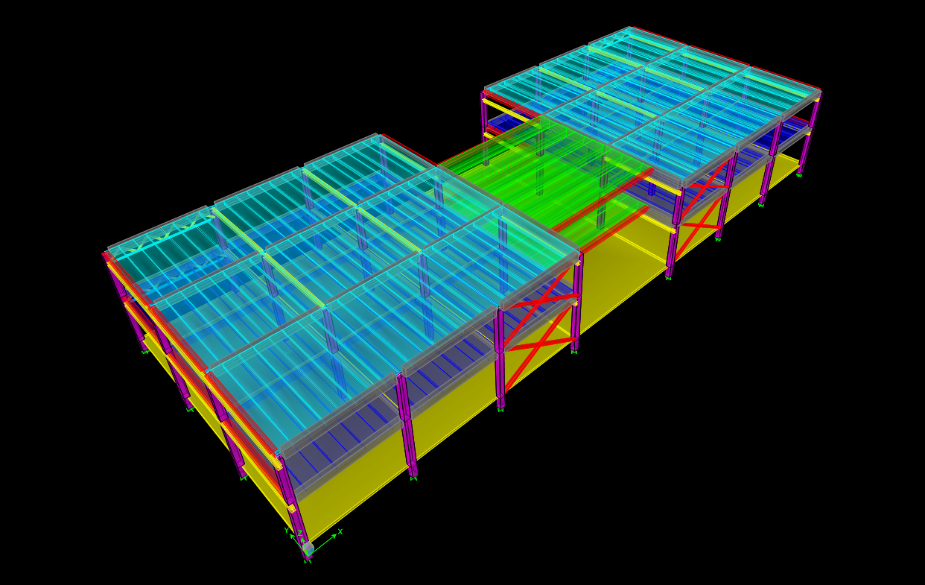

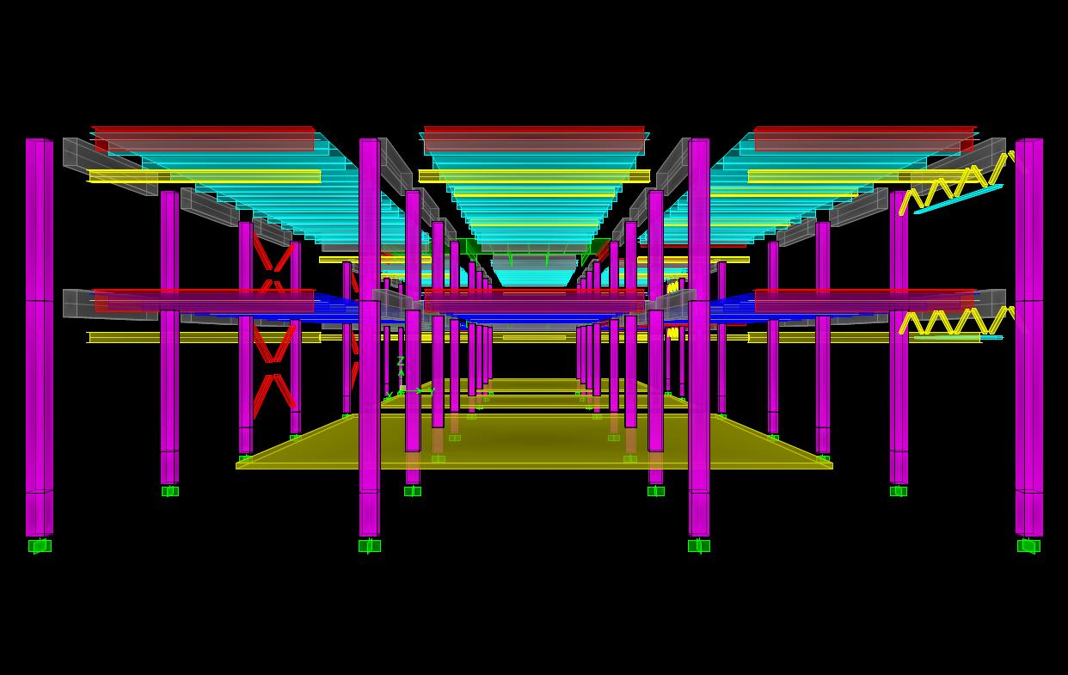

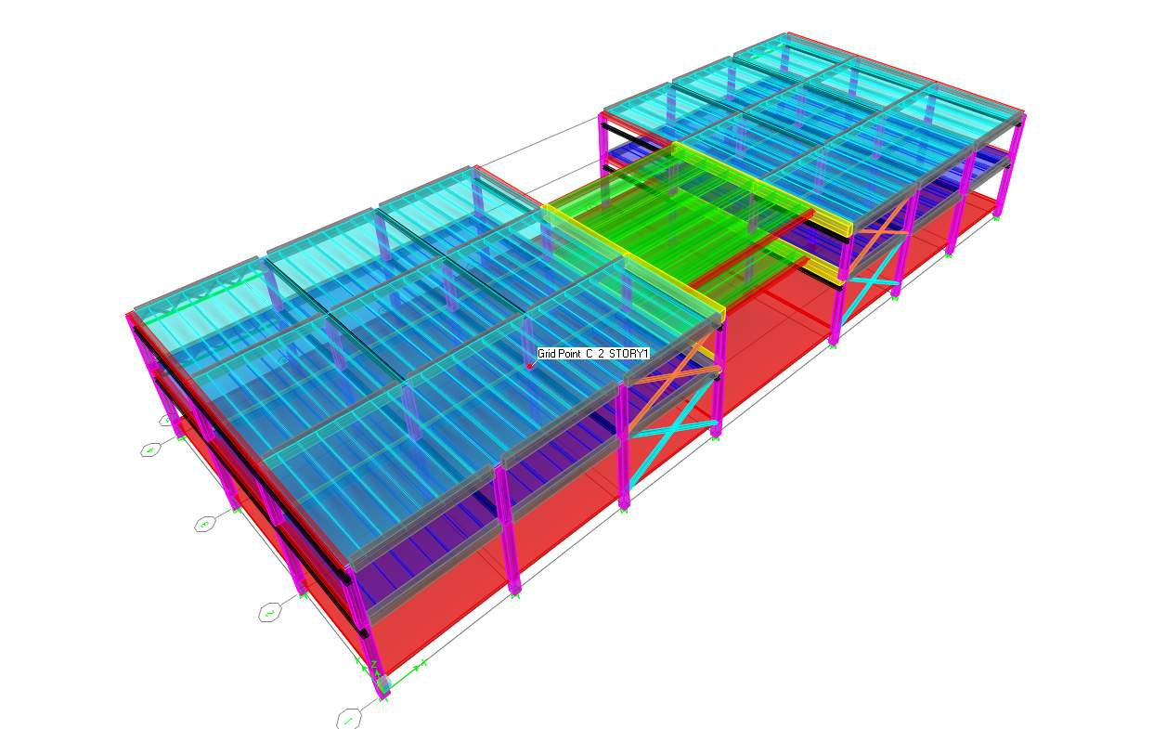

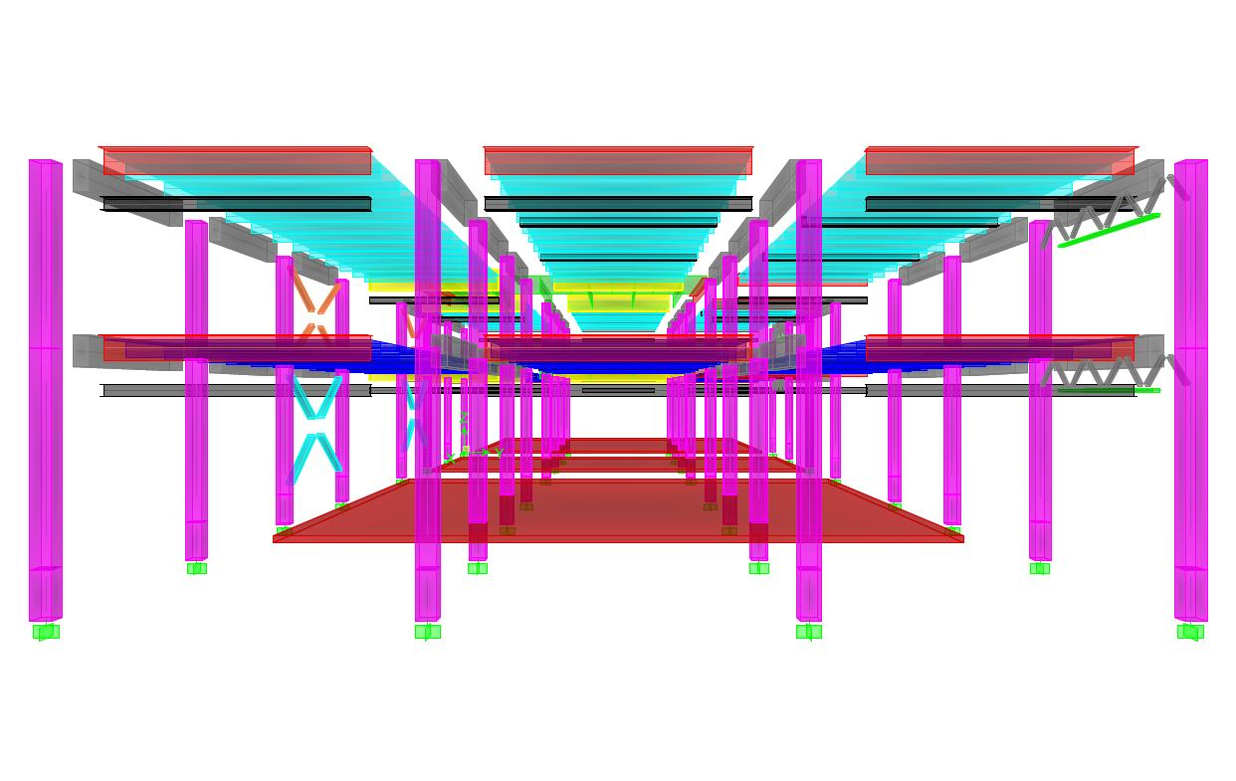

INPUT FILE

- izneseni su samo osnovni podaci o modelu

- prikazano je zadano opterećenje i poprečni presjeci

S T O R Y D A T A
STORY SIMILAR TO HEIGHT ELEVATION

STORY2 None 4,400 10,800
STORY1 None 5,200 6,400
BAZNA None 1,200 1,200
BASE None 0,000

M A S S S O U R C E L O A D S
LOAD MULTIPLIER

SLOJEVI 1,0000
POKRETNO 0,9000
SNIJEG 0,9000

D I A P H R A G M M A S S D A T A
STORY DIAPHRAGM MASS-X MASS-Y MMI X-M Y-M

STORY1 D1 2356,0855 2356,0855 1189295 34,100 13,038
BAZNA D1 2335,5614 2335,5614 1250662 34,100 13,492

G R O U P M A S S D A T A
GROUP SELF SELF TOTAL TOTAL TOTAL
NAME MASS WEIGHT MASS-X MASS-Y MASS-Z

ALL 2741,2259 26903,917 6308,7158 6308,7158 0,0000
1_STUP 99,8683 980,163 199,8171 199,8171 0,0000
2_STUP 84,5039 829,369 169,0760 169,0760 0,0000
2_GL_GR 152,1071 1492,864 304,3368 304,3368 0,0000
1_GL_GR 146,1164 1434,067 292,3506 292,3506 0,0000
1_POP_GR 80,8078 793,093 161,6809 161,6809 0,0000
2_POP_GR 80,8078 793,093 161,6809 161,6809 0,0000
1_PI 551,9087 5416,740 1684,5573 1684,5573 0,0000
0_STUP 23,0465 226,191 46,1116 46,1116 0,0000
DIJAG 5,1903 50,940 10,3847 10,3847 0,0000
OJACANJE2 6,0143 59,028 12,0335 12,0335 0,0000
OJACANJE1 15,5401 152,519 37,9372 37,9372 0,0000

M A T E R I A L L I S T B Y E L E M E N T T Y P E
ELEMENT TOTAL NUMBER NUMBER
TYPE MATERIAL MASS PIECES STUDS
tons

Column CONC 207,59 96
Beam STEEL 32,37 44 0
Beam CONC 1391,40 232 0
Brace STEEL 6,03 48
Floor CONC 1106,04

M A T E R I A L L I S T B Y S E C T I O N
ELEMENT NUMBER TOTAL TOTAL NUMBER
SECTION TYPE PIECES LENGTH MASS STUDS
meters tons

GL-GR Beam 48 432,000 304,46 0
PI-1 Beam 72 648,000 469,72 0
PI-SREDNJI Beam 12 170,400 165,28 0
PI-2 Beam 72 648,000 290,21 0
POPRECNE Beam 20 200,800 71,89 0
STUP Column 96 345,600 207,59
POPRECNI-SR Beam 8 72,000 89,86 0
TUBO220X110 Brace 8 40,072 2,39
TUBO100X100 Brace 32 48,166 0,84
HE300-A Beam 40 360,000 30,98 0
TUBO160X80X Beam 4 36,000 1,39 0
TUBO300X150 Brace 8 41,577 2,80
DONJAPL Floor 1106,04

M A T E R I A L L I S T B Y S T O R Y
ELEMENT TOTAL FLOOR UNIT NUMBER NUMBER
STORY TYPE MATERIAL WEIGHT AREA WEIGHT PIECES STUDS
tons m2 kg/m2

STORY2 Column CONC 84,57 0,000 32
STORY2 Beam STEEL 14,68 0,000 20 0
STORY2 Beam CONC 605,95 0,000 116 0
STORY2 Brace STEEL 2,81 0,000 24

STORY1 Column CONC 99,95 0,000 32
STORY1 Beam STEEL 17,69 0,000 24 0
STORY1 Beam CONC 785,46 0,000 116 0
STORY1 Brace STEEL 3,22 0,000 24

BAZNA Column CONC 23,07 1841,400 12,5259 32
BAZNA Floor CONC 1106,04 1841,400 600,6539

SUM Column CONC 207,59 1841,400 112,7327 96
SUM Beam STEEL 32,37 1841,400 17,5793 44 0
SUM Beam CONC 1391,40 1841,400 755,6223 232 0
SUM Brace STEEL 6,03 1841,400 3,2760 48
SUM Floor CONC 1106,04 1841,400 600,6539

TOTAL All All 2743,44 1841,400 1489,8642 420 0

M A T E R I A L P R O P E R T Y D A T A
MATERIAL MATERIAL DESIGN MATERIAL MODULUS OF POISSON'S THERMAL SHEAR
NAME TYPE TYPE DIR/PLANE ELASTICITY RATIO COEFF MODULUS

STEEL Iso Steel All 199948000 0,3000 1,1700E-05 76903077
CONC Iso Concrete All 24821130 0,2000 9,9000E-06 10342138
OTHER Iso None All 199900000 0,3000 1,1700E-05 76884615

M A T E R I A L P R O P E R T Y M A S S A N D W E I G H T
MATERIAL MASS PER WEIGHT PER
NAME UNIT VOL UNIT VOL

STEEL 7,8271E+00 7,6820E+01
CONC 2,4007E+00 2,3562E+01
OTHER 0,0000E+00 0,0000E+00

MATERIAL D E S I G N D A T A F O R S T E E L M A T E R I A L S
MATERIAL STEEL STEEL STEEL
NAME FY FU COST ($)

STEEL 344737,900 448159,300 271447,20

MATERIAL D E S I G N D A T A F O R C O N C R E T E M A T E R I A L S
MATERIAL LIGHTWEIGHT CONCRETE REBAR REBAR LIGHTWT
NAME CONCRETE FC FY FYS REDUC FACT

CONC No 27579,030 413685,500 413685,500 N/A

F R A M E S E C T I O N P R O P E R T Y D A T A
MATERIAL SECTION SHAPE NAME OR NAME CONC CONC
FRAME SECTION NAME NAME IN SECTION DATABASE FILE COL BEAM

GL-GR CONC Rectangular Yes
PI-1 CONC Tee Yes
PI-SREDNJI CONC Tee Yes
PI-2 CONC Tee Yes
POPRECNE CONC Tee Yes
STUP CONC Rectangular Yes
POPRECNI-SRE CONC Rectangular Yes
TUBO220X110X12.5 STEEL TUBO220X110X12.5
TUBO100X100X5.9 STEEL TUBO100X100X5.9
HE300-A STEEL HE300-A
TUBO160X80X12.5 STEEL TUBO160X80X12.5
TUBO300X150X10 STEEL TUBO300X150X10

F R A M E S E C T I O N P R O P E R T Y D A T A
SECTION FLANGE FLANGE WEB FLANGE FLANGE
FRAME SECTION NAME DEPTH WIDTH TOP THICK TOP THICK WIDTH BOT THICK BOT

GL-GR 0,8000 0,4000 0,0000 0,0000 0,4000 0,0000
PI-1 0,4000 2,2500 0,0900 0,3200 2,2500 0,0900
PI-SREDNJI 0,8000 2,4300 0,0700 0,3200 2,4300 0,0700
PI-2 0,4000 2,2000 0,0600 0,1600 2,2000 0,0600
POPRECNE 0,6000 0,5000 0,2000 0,1400 0,5000 0,2000
STUP 0,5000 0,5000 0,0000 0,0000 0,5000 0,0000
POPRECNI-SRE 1,0000 0,5500 0,0000 0,0000 0,5500 0,0000
TUBO220X110X12.5 0,2200 0,1100 0,0125 0,0125 0,0000 0,0000
TUBO100X100X5.9 0,1000 0,1000 0,0059 0,0059 0,0000 0,0000
HE300-A 0,2900 0,3000 0,0140 0,0085 0,3000 0,0140
TUBO160X80X12.5 0,1600 0,0800 0,0125 0,0125 0,0000 0,0000
TUBO300X150X10 0,3000 0,1500 0,0100 0,0100 0,0000 0,0000

F R A M E S E C T I O N P R O P E R T Y D A T A
SECTION TORSIONAL MOMENTS OF INERTIA SHEAR AREAS
FRAME SECTION NAME AREA CONSTANT I33 I22 A2 A3

GL-GR 0,3200 0,0117 0,0171 0,0043 0,2667 0,2667
PI-1 0,3017 0,0032 0,0036 0,0863 0,1280 0,1688
PI-SREDNJI 0,4037 0,0075 0,0262 0,0857 0,2560 0,1418
PI-2 0,1864 0,0006 0,0021 0,0534 0,0640 0,1100
POPRECNE 0,1560 0,0015 0,0043 0,0022 0,0840 0,0833
STUP 0,2500 0,0088 0,0052 0,0052 0,2083 0,2083
POPRECNI-SRE 0,5500 0,0364 0,0458 0,0139 0,4583 0,4583
TUBO220X110X12.5 0,0076 0,0000 0,0000 0,0000 0,0055 0,0028
TUBO100X100X5.9 0,0022 0,0000 0,0000 0,0000 0,0012 0,0012
HE300-A 0,0113 0,0000 0,0002 0,0001 0,0025 0,0070
TUBO160X80X12.5 0,0054 0,0000 0,0000 0,0000 0,0040 0,0020
TUBO300X150X10 0,0086 0,0001 0,0001 0,0000 0,0060 0,0030

F R A M E S E C T I O N P R O P E R T Y D A T A
SECTION MODULI PLASTIC MODULI RADIUS OF GYRATION
FRAME SECTION NAME S33 S22 Z33 Z22 R33 R22

GL-GR 0,0427 0,0213 0,0640 0,0320 0,2309 0,1155
PI-1 0,0124 0,0767 0,0233 0,1218 0,1092 0,5348
PI-SREDNJI 0,0491 0,0705 0,0881 0,1220 0,2547 0,4607
PI-2 0,0068 0,0485 0,0125 0,0748 0,1063 0,5350
POPRECNE 0,0110 0,0087 0,0202 0,0145 0,1662 0,1181
STUP 0,0208 0,0208 0,0313 0,0313 0,1443 0,1443
POPRECNI-SRE 0,0917 0,0504 0,1375 0,0756 0,2887 0,1588
TUBO220X110X12.5 0,0004 0,0003 0,0005 0,0003 0,0769 0,0435
TUBO100X100X5.9 0,0001 0,0001 0,0001 0,0001 0,0385 0,0385
HE300-A 0,0013 0,0004 0,0014 0,0006 0,1271 0,0747
TUBO160X80X12.5 0,0002 0,0001 0,0003 0,0002 0,0546 0,0304
TUBO300X150X10 0,0007 0,0004 0,0008 0,0005 0,1077 0,0620

F R A M E S E C T I O N W E I G H T S A N D M A S S E S

TOTAL TOTAL
FRAME SECTION NAME WEIGHT MASS

GL-GR 2985,7272 304,2142
PI-1 4606,3325 469,3368
PI-SREDNJI 1620,8145 165,1439
PI-2 2845,9409 289,9714
POPRECNE 704,9822 71,8303
STUP 2035,7231 207,4188
POPRECNI-SRE 881,2042 89,7854
TUBO220X110X12.5 23,4723 2,3916
TUBO100X100X5.9 8,2180 0,8373
HE300-A 303,8213 30,9562
TUBO160X80X12.5 13,6259 1,3883
TUBO300X150X10 27,4677 2,7987

C O N C R E T E C O L U M N D A T A

REINF CONFIGURATION REINF NUM BARS NUM BARS BAR
FRAME SECTION NAME LONGIT LATERAL SIZE/TYPE 3DIR/2DIR CIRCULAR COVER

STUP Rectangular Ties 14Ř/Design 3/3 N/A 0,0400

C O N C R E T E B E A M D A T A

TOP BOT TOP LEFT TOP RIGHT BOT LEFT BOT RIGHT
FRAME SECTION NAME COVER COVER AREA AREA AREA AREA

GL-GR 0,0800 0,0800 0,000 0,000 0,000 0,000
PI-1 0,0152 0,0152 0,000 0,000 0,000 0,000
PI-SREDNJI 0,0152 0,0152 0,000 0,000 0,000 0,000
PI-2 0,0400 0,0400 0,000 0,000 0,000 0,000
POPRECNE 0,0600 0,0600 0,000 0,000 0,000 0,000
POPRECNI-SRE 0,1000 0,1000 0,000 0,000 0,000 0,000

S H E L L S E C T I O N P R O P E R T Y D A T A

SHELL MATERIAL SHELL LOAD DIST MEMBRANE BENDING TOTAL TOTAL
SECTION NAME TYPE ONE WAY THICK THICK WEIGHT MASS

DONJAPL CONC Membrane No 0,2500 0,2500 10846,5872 1105,1530

S T A T I C L O A D C A S E S

STATIC CASE AUTO LAT SELF WT
CASE TYPE LOAD MULTIPLIER

DEAD DEAD N/A 1,0000
SLOJEVI DEAD N/A 1,0000
POKRETNO LIVE N/A 0,0000
SNIJEG LIVE N/A 0,0000

R E S P O N S E S P E C T R U M C A S E S

*****************************
RESP SPEC CASE: EC1
*****************************

BASIC RESPONSE SPECTRUM DATA

MODAL DIRECTION MODAL SPECTRUM
COMBO COMBO DAMPING ANGLE

CQC SRSS 0,0000 0,0000

RESPONSE SPECTRUM FUNCTION ASSIGNMENT DATA

DIRECTION FUNCTION SCALE FACT

U1 EC 4,0000
U2 EC 4,0000
UZ ---- N/A

L O A D I N G C O M B I N A T I O N S

COMBO CASE SCALE
COMBO TYPE CASE TYPE FACTOR

STAT ADD DEAD Static 1,3500
SLOJEVI Static 1,3500
POKRETNO Static 1,3500
SNIJEG Static 1,3500

DIN ADD DEAD Static 1,0000
SLOJEVI Static 1,0000
POKRETNO Static 0,3000
EC1 Spectra 1,0000
SNIJEG Static 0,3000

R E S P O N S E S P E C T R U M F U N C T I O N - E U R O C O D E 8

FUNCTION NAME: EC

SOIL CLASS Ag DAMP FACT

B 0,2000 1,0000

PERIOD ACCEL

0,0000 0,2000
0,1000 0,4000
0,1500 0,5000
0,2000 0,5000
0,4000 0,5000
0,6000 0,5000
0,8000 0,3750
1,0000 0,3000
1,5000 0,2000
2,0000 0,1500
2,5000 0,1200
3,0000 0,1000
4,0000 0,0563
5,0000 0,0360
6,0000 0,0250
8,0000 0,0141
10,0000 0,0090

*************************poseban file ova stranica************************
-------------------------razdjeljena u tri stranice-----------------------

OPTEREĆENJA:

(zadani kao linijsko po pi-nosačima)

stalno-slojevi:

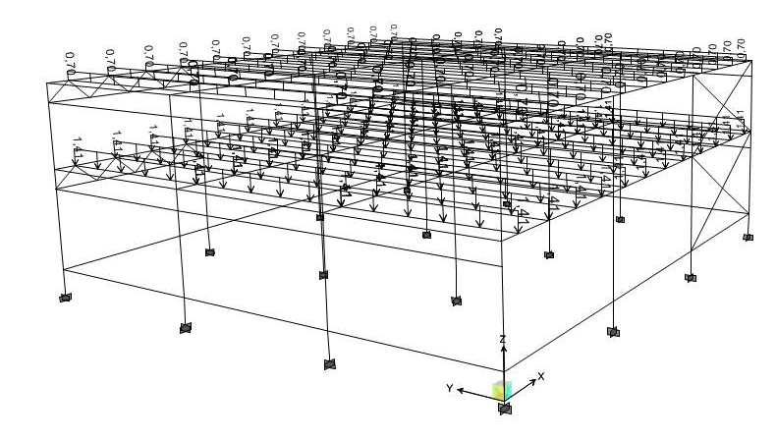
pokretno:

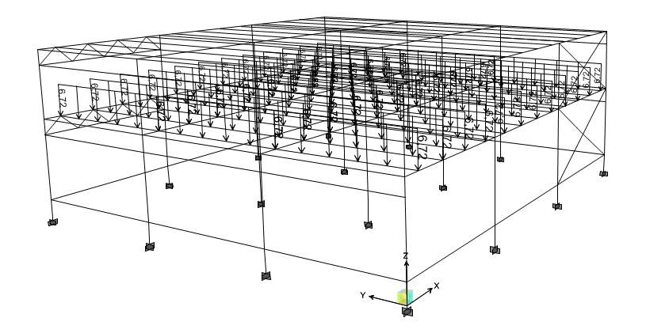

snijeg:

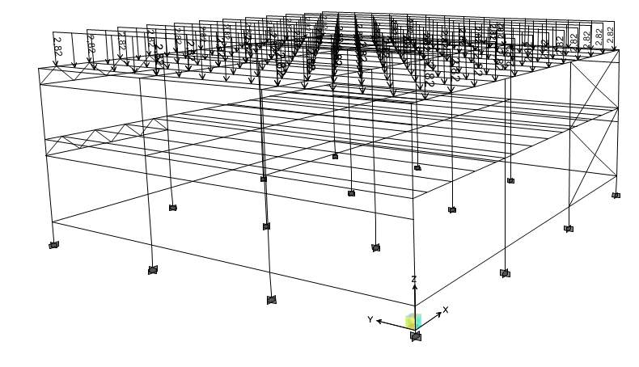

GL_GR

HE 300 A

PI-1

PI-2

PI-SREDNJI

POPRECNE

POPRECNI_SRE

STUP

*** još su ostali TUB-ovi koje smo koristili u vertikalnim stabilizacijama, koji su vađeni iz tablica EC

OUTPUT FILE

- izneseni su samo osnovni podaci o modelu ostale podatke mogu se pronaći u datoteci output.txt priloženoj uz projekt

M O D E S H A P E S

STORY DIAPHRAGM MODE UX UY UZ RX RY RZ

STORY1 D1 Mode 1 0,00000 0,01093 0,00000 0,00000 0,00000 0,00000
STORY1 D1 Mode 2 0,00577 0,00000 0,00000 0,00000 0,00000 -0,00045
STORY1 D1 Mode 3 -0,00817 0,00000 0,00000 0,00000 0,00000 -0,00019
STORY1 D1 Mode 4 0,00000 0,01306 0,00000 0,00000 0,00000 0,00000
STORY1 D1 Mode 5 0,00315 -0,00001 0,00000 0,00000 0,00000 -0,00058
STORY1 D1 Mode 6 0,00000 -0,01129 0,00000 0,00000 0,00000 0,00000

BAZNA D1 Mode 1 0,00000 0,00052 0,00000 0,00000 0,00000 0,00000
BAZNA D1 Mode 2 0,00030 0,00000 0,00000 0,00000 0,00000 -0,00003
BAZNA D1 Mode 3 -0,00067 0,00000 0,00000 0,00000 0,00000 -0,00002
BAZNA D1 Mode 4 0,00000 0,00121 0,00000 0,00000 0,00000 0,00000
BAZNA D1 Mode 5 0,00023 0,00000 0,00000 0,00000 0,00000 -0,00007
BAZNA D1 Mode 6 0,00000 -0,00130 0,00000 0,00000 0,00000 0,00000

M O D A L P E R I O D S A N D F R E Q U E N C I E S

MODE PERIOD FREQUENCY CIRCULAR FREQ
NUMBER (TIME) (CYCLES/TIME) (RADIANS/TIME)

Mode 1 1,62983 0,61356 3,85512
Mode 2 1,34941 0,74107 4,65625
Mode 3 0,65459 1,52768 9,59868
Mode 4 0,42928 2,32951 14,63673
Mode 5 0,38486 2,59834 16,32583
Mode 6 0,37543 2,66362 16,73599

M O D A L P A R T I C I P A T I O N F A C T O R S

MODE UX UY UZ RX RY RZ

Mode 1 0,0031 -60,6872 0,0000 529,1714 0,0261 -0,1393
Mode 2 -30,4204 -0,0069 0,0000 0,0596 -261,3471 1200,7274
Mode 3 50,8574 -0,0011 0,0000 0,0055 448,4848 641,4263
Mode 4 -0,0037 -18,6758 0,0000 37,7176 -0,0281 -0,0763
Mode 5 0,7698 0,0093 0,0000 -0,0094 46,4040 487,4255
Mode 6 -0,0022 15,2623 0,0000 -17,4752 -0,0435 -0,3708

M O D A L P A R T I C I P A T I N G M A S S R A T I O S

MODE X-TRANS Y-TRANS Z-TRANS RX-ROTN RY-ROTN RZ-ROTN
NUMBER %MASS <SUM> %MASS <SUM> %MASS <SUM> %MASS <SUM> %MASS <SUM> %MASS <SUM>

Mode 1 0,00 < 0> 58,59 < 59> 0,00 < 0> 98,78 < 99> 0,00 < 0> 0,00 < 0>
Mode 2 14,72 < 15> 0,00 < 59> 0,00 < 0> 0,00 < 99> 24,09 < 24> 44,59 < 45>
Mode 3 41,15 < 56> 0,00 < 59> 0,00 < 0> 0,00 < 99> 70,95 < 95> 12,72 < 57>
Mode 4 0,00 < 56> 5,55 < 64> 0,00 < 0> 0,50 < 99> 0,00 < 95> 0,00 < 57>
Mode 5 0,01 < 56> 0,00 < 64> 0,00 < 0> 0,00 < 99> 0,76 < 96> 7,35 < 65>
Mode 6 0,00 < 56> 3,71 < 68> 0,00 < 0> 0,11 < 99> 0,00 < 96> 0,00 < 65>

M O D A L L O A D P A R T I C I P A T I O N R A T I O S

(STATIC AND DYNAMIC RATIOS ARE IN PERCENT)

TYPE LOAD ACCEL STORY LINK DOF STATIC DYNAMIC

Load DEAD 0,0005 0,0004
Load SLOJEVI 0,0005 0,0004
Load POKRETNO 0,0009 0,0000
Load SNIJEG 0,0005 0,0000

Accel UX 96,7115 55,8806
Accel UY 99,8382 67,8475
Accel UZ 0,0000 0,0000
Accel RX 99,9981 99,3868
Accel RY 99,5389 95,8043
Accel RZ 80,1243 64,6581

R E S P O N S E S P E C T R U M A C C E L E R A T I O N S
(IN RESPONSE SPECTRUM LOCAL COORDINATES)
SPEC MODE PERIOD DAMP-RATIO SPEC-FACTOR U1 U2 U3

EC1 Mode 1 1,629830 0,000000 1,000000 0,748068 0,748068 0,000000
EC1 Mode 2 1,349408 0,000000 1,000000 0,920474 0,920474 0,000000
EC1 Mode 3 0,654588 0,000000 1,000000 1,863530 1,863530 0,000000
EC1 Mode 4 0,429275 0,000000 1,000000 2,000000 2,000000 0,000000
EC1 Mode 5 0,384862 0,000000 1,000000 2,000000 2,000000 0,000000
EC1 Mode 6 0,375430 0,000000 1,000000 2,000000 2,000000 0,000000

R E S P O N S E S P E C T R U M M O D A L A M P L I T U D E S
(IN RESPONSE SPECTRUM LOCAL COORDINATES)
SPEC MODE PERIOD U1 U2 U3

EC1 Mode 1 1,629830 -0,000155 3,054662 0,000000
EC1 Mode 2 1,349408 1,291527 0,000295 0,000000
EC1 Mode 3 0,654588 -1,028648 0,000022 0,000000
EC1 Mode 4 0,429275 0,000034 0,174349 0,000000
EC1 Mode 5 0,384862 -0,005777 -0,000069 0,000000
EC1 Mode 6 0,375430 0,000016 -0,108980 0,000000

R E S P O N S E S P E C T R U M B A S E R E A C T I O N S
(IN RESPONSE SPECTRUM LOCAL COORDINATES)

SPEC MODE DIR F1 F2 F3 M1 M2 M3

EC1 Mode 1 U1 0,00 -0,14 0,00 1,219 0,000 -4,768
EC1 Mode 2 U1 851,81 0,19 0,00 -1,668 7318,030 -28910,049
EC1 Mode 3 U1 4819,96 -0,10 0,00 0,518 42504,782 -26836,353
EC1 Mode 4 U1 0,00 0,14 0,00 -0,276 0,000 4,666
EC1 Mode 5 U1 1,19 0,01 0,00 -0,014 71,446 -468,102
EC1 Mode 6 U1 0,00 -0,07 0,00 0,077 0,000 -2,303

EC1 Mode 1 U2 -0,14 2755,09 0,00 -24023,413 -1,186 93953,707
EC1 Mode 2 U2 0,19 0,00 0,00 0,000 1,669 -6,595
EC1 Mode 3 U2 -0,10 0,00 0,00 0,000 -0,895 0,565
EC1 Mode 4 U2 0,14 697,57 0,00 -1408,811 1,051 23784,916
EC1 Mode 5 U2 0,01 0,00 0,00 0,000 0,859 -5,629
EC1 Mode 6 U2 -0,07 465,88 0,00 -533,426 -1,329 15893,83

EC1 All All 4894,65 2879,96 0,00 24070,597 43130,211 105838,723

CENTERS OF CUMULATIVE MASS & CENTERS OF R I G I D I T Y
STORY DIAPHRAGM /----------CENTER OF MASS----------//--CENTER OF RIGIDITY--/
LEVEL NAME MASS ORDINATE-X ORDINATE-Y ORDINATE-X ORDINATE-Y

STORY1 D1 2356,0855 34,100 13,038 34,099 3,574

BAZNA D1 4691,6469 34,100 13,264 34,100 12,181

S T O R Y F O R C E S
STORY LOAD LOCATION P VX VY T MX MY

STORY2 STAT Top 20202,36 0,00 0,00 0,000 261313,742 -688900,539
Bottom 22747,13 0,00 0,00 0,000 295230,554 -775677,076

STORY2 DIN MAX Top 13506,64 2840,46 1669,54 61465,020 174382,738 -460576,140
Bottom 15391,66 2871,22 1685,58 62114,077 207496,427 -512029,065

STORY2 DIN MIN Top 13506,64 -2840,46 -1669,54 -61465,020 174382,720 -460576,740
Bottom 15391,66 -2871,22 -1685,58 -62114,077 191517,052 -537681,649

STORY1 STAT Top 52632,95 0,00 0,00 0,000 684234,486 -1794783
Bottom 55595,65 0,00 0,00 0,000 723646,781 -1895812

STORY1 DIN MAX Top 34045,73 4733,01 2779,27 104297,909 449838,416 -1148133
Bottom 36240,33 4744,89 2789,59 104696,173 493928,361 -1197880

STORY1 DIN MIN Top 34045,73 -4733,01 -2779,27 -104297,909 433859,040 -1173786
Bottom 36240,33 -4744,89 -2789,59 -104696,174 448158,849 -1273710

BAZNA STAT Top 84881,44 0,00 0,00 0,000 1119004,883 -2894457
Bottom 85492,15 0,00 0,00 0,000 1127249,401 -2915282

BAZNA DIN MAX Top 57933,50 4894,69 2879,96 108010,467 786786,214 -1937617
Bottom 58385,88 4894,69 2879,96 108010,467 796356,632 -1947113

BAZNA DIN MIN Top 57933,50 -4894,69 -2879,96 -108010,467 741016,703 -2013448
Bottom 58385,88 -4894,69 -2879,96 -108010,467 743660,436 -2034804

UNUTARNJE SILE

- iznesene su unutarnje sile samo u onim elementima koji su dimenzionirani, a ostale se može naći u datoteci output.txt priloženoj uz projekt

- pokazani su osnovni dijagrami na karakterističnim presjecima, shema presjeka je priložena u prilogu

