PRESJEK 1:
M 3-3 M 2-2
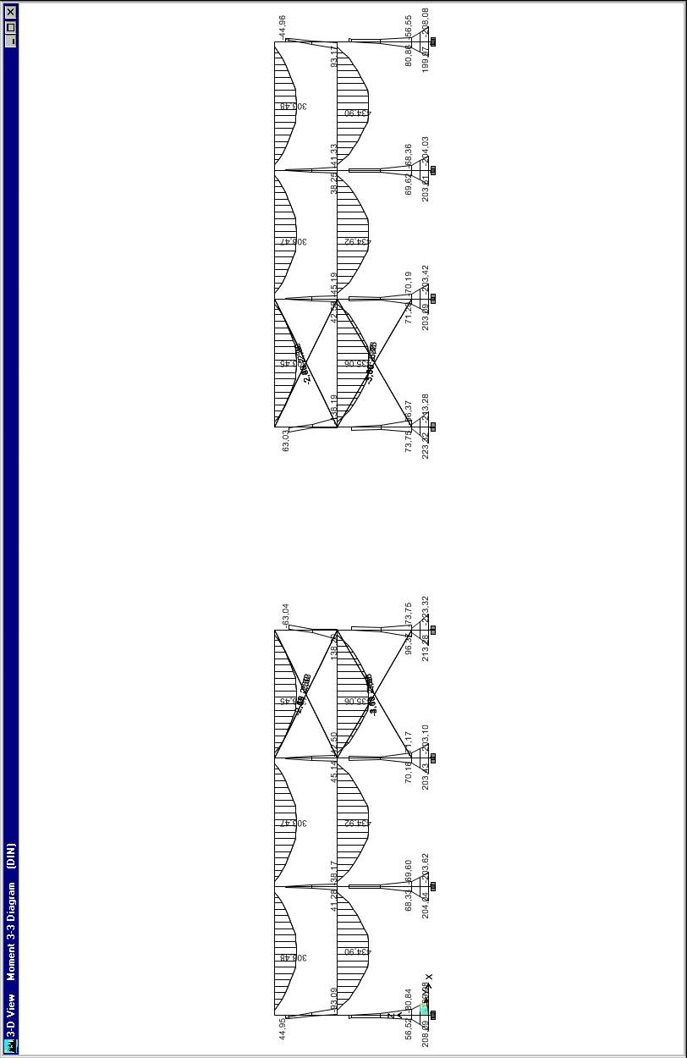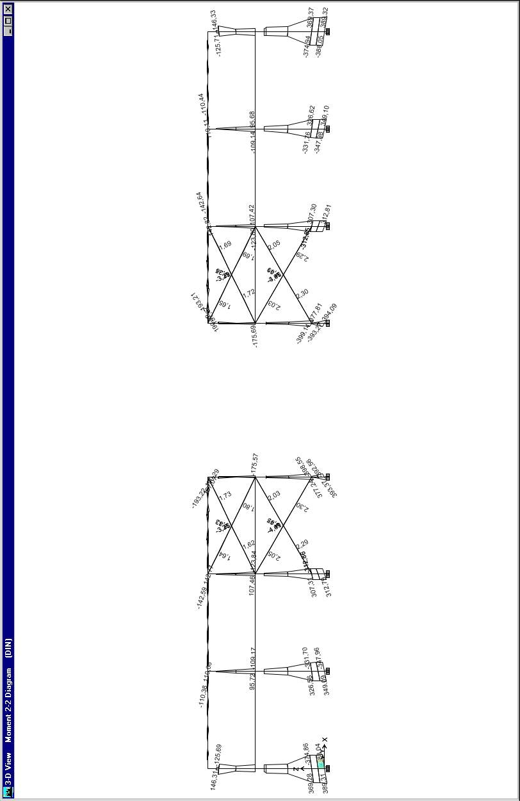
T 2-2 N
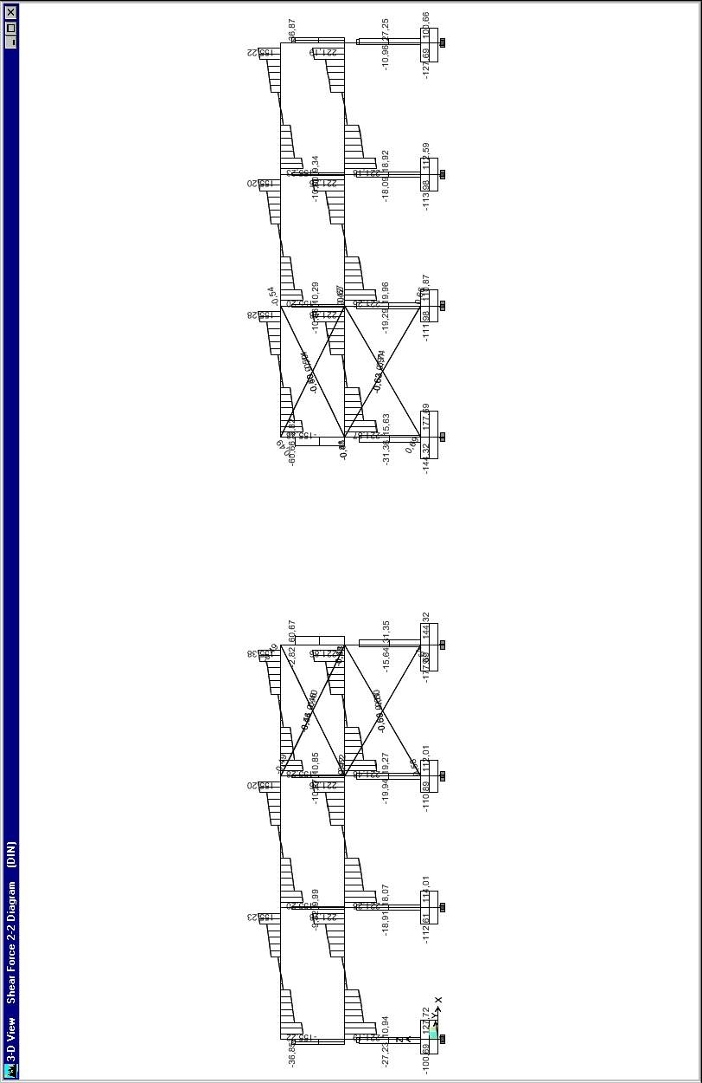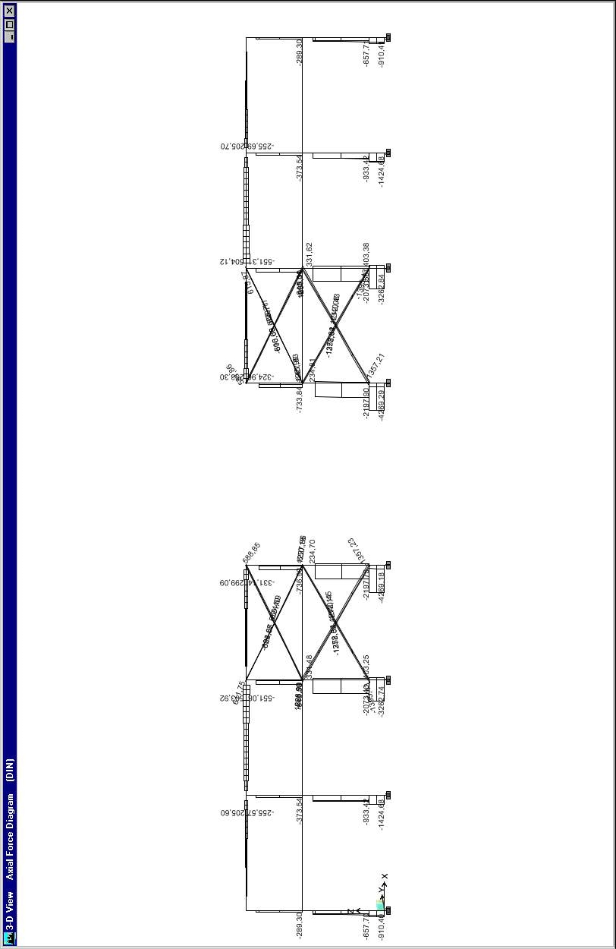
PRESJEK 4:
M 3-3 M 2-2
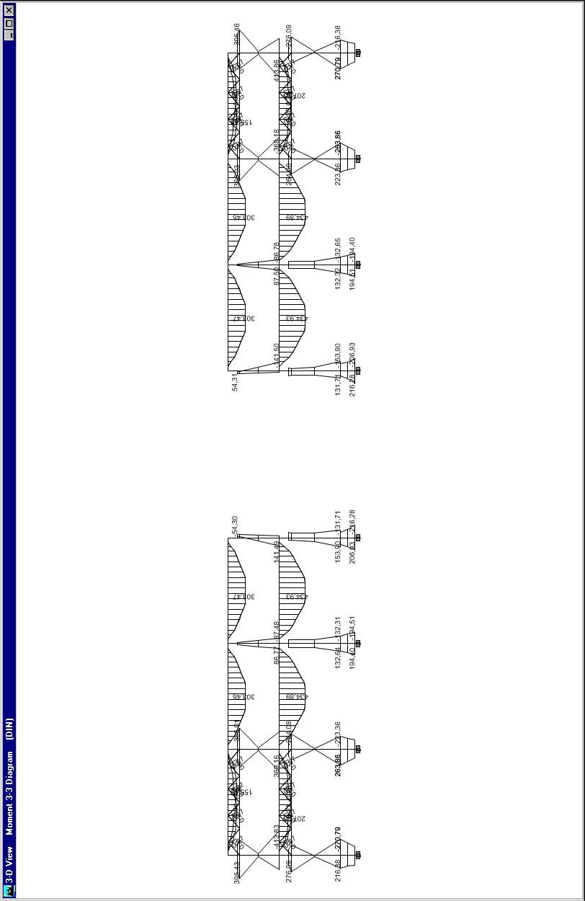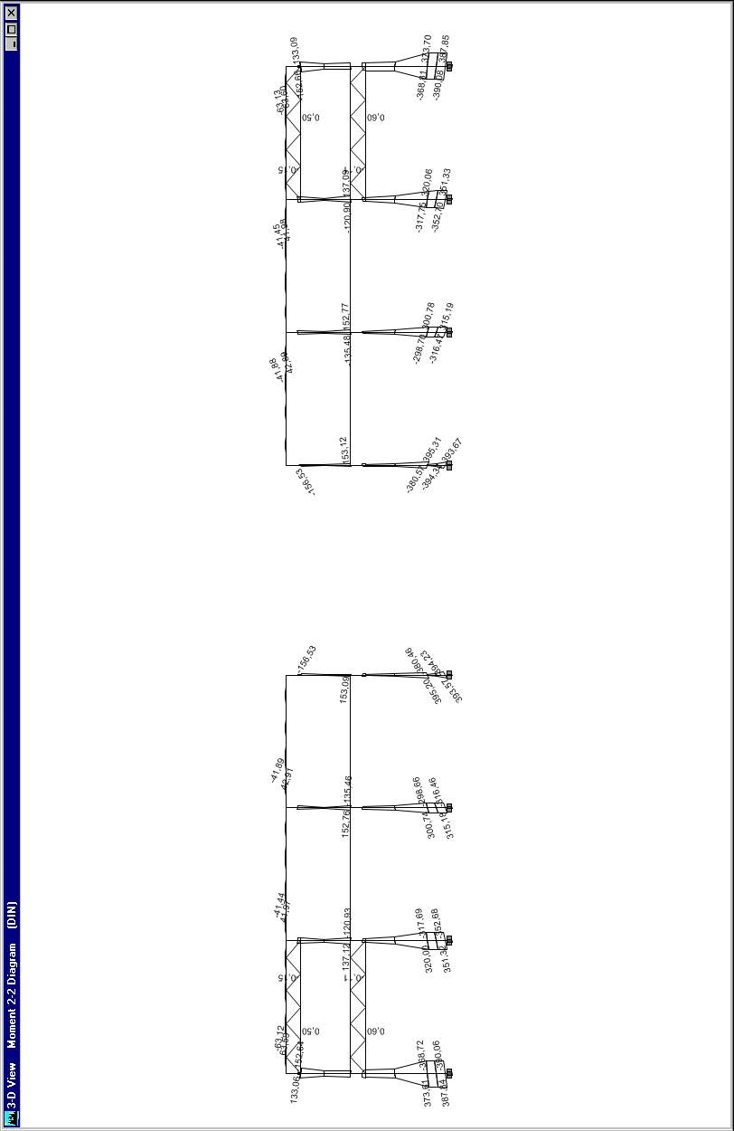
T 2-2 N
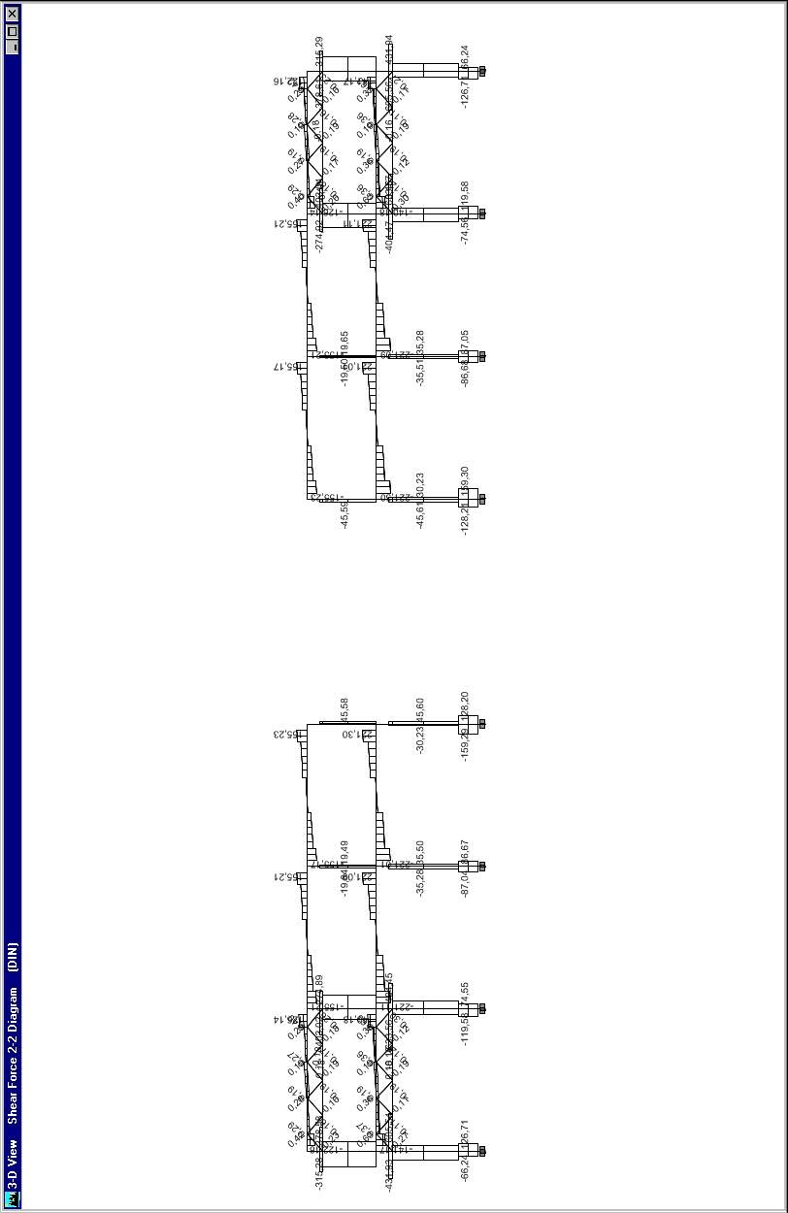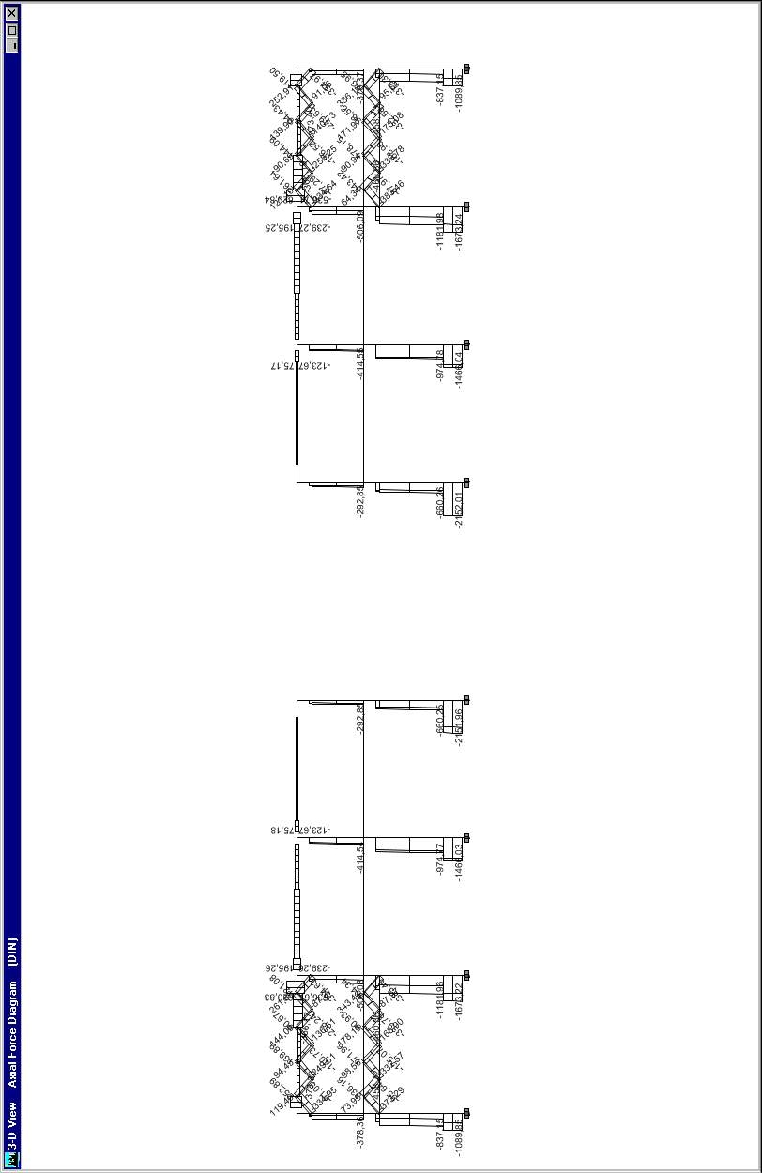

PRESJEK E:

M 3-3
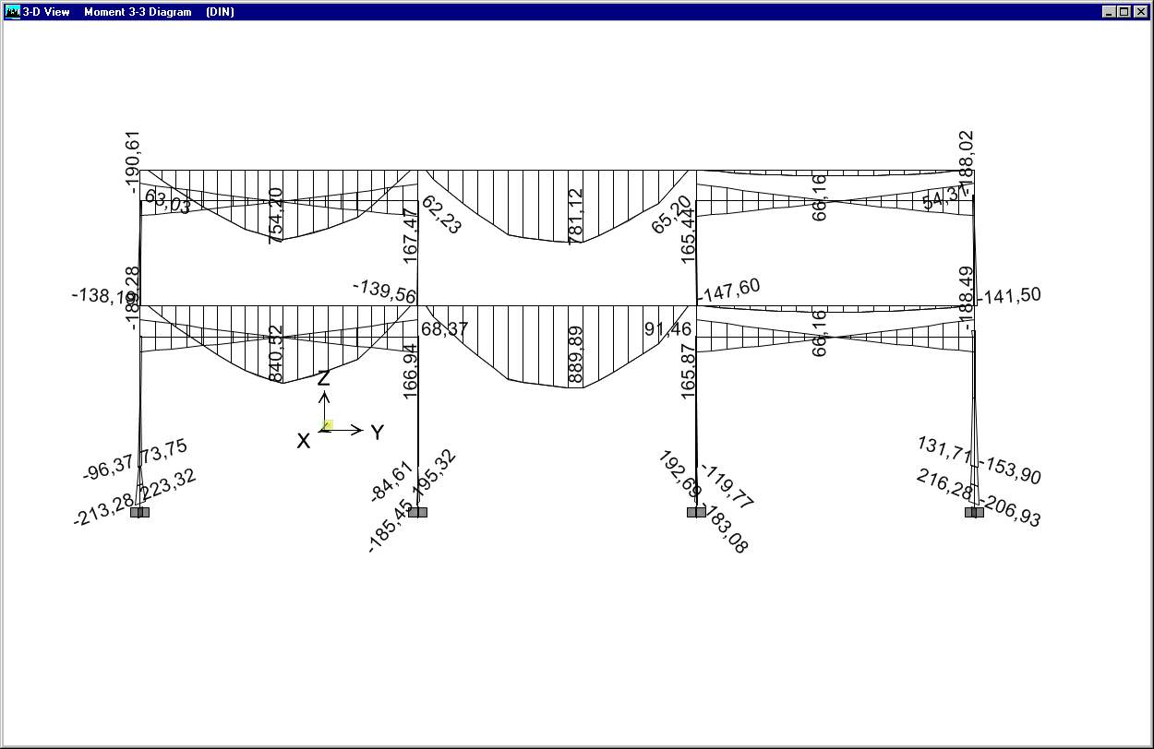
M 2-2
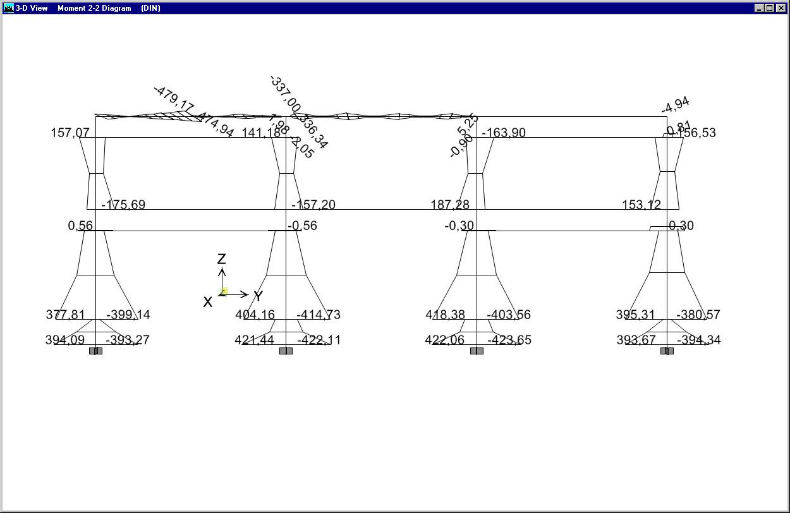
N

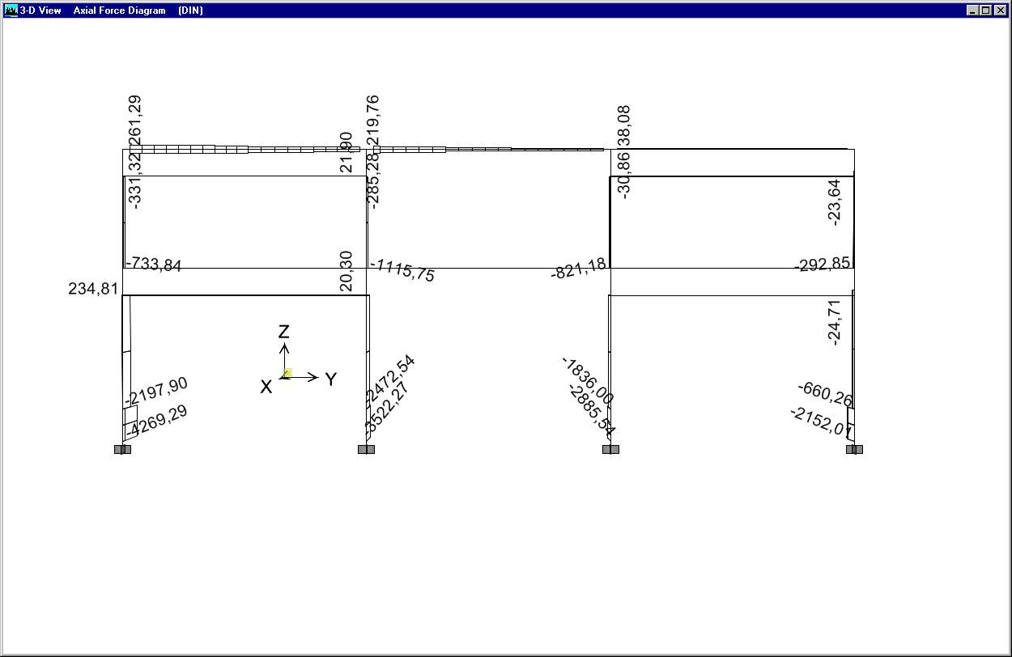

T 3-3
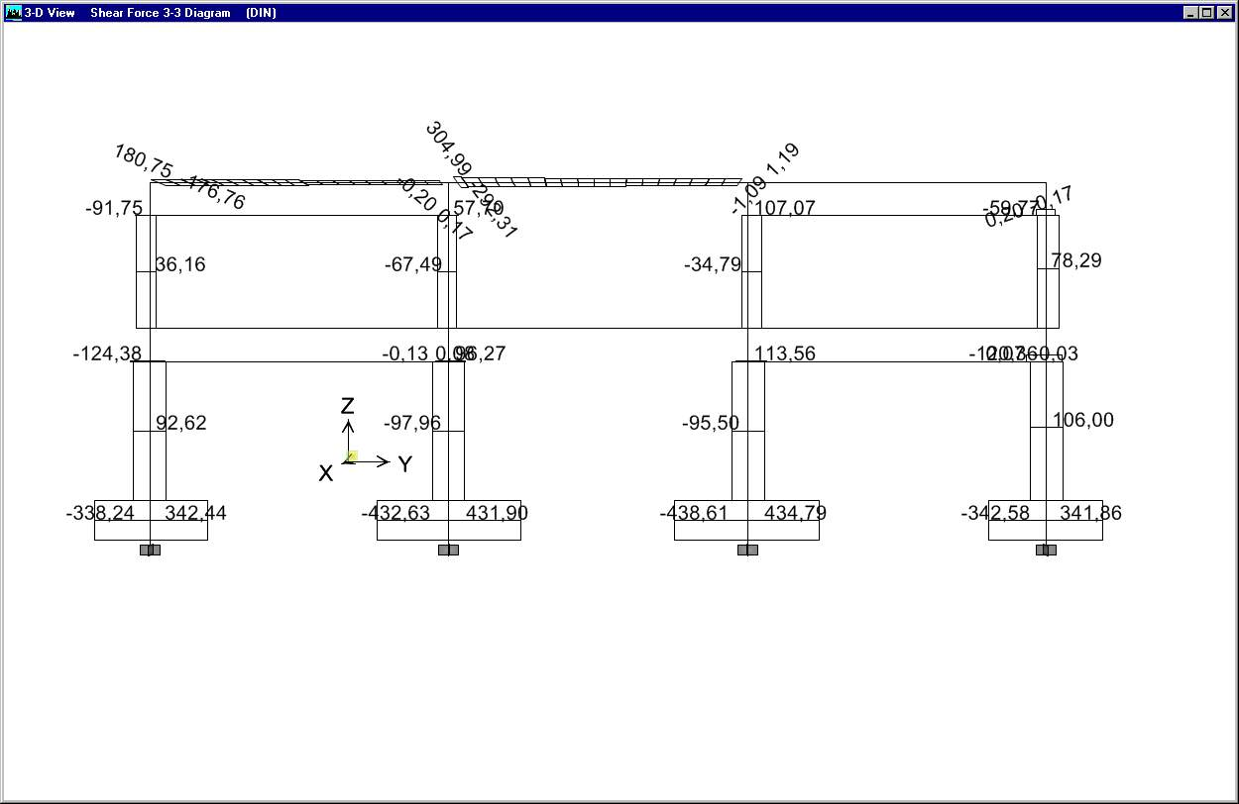

T 2-2
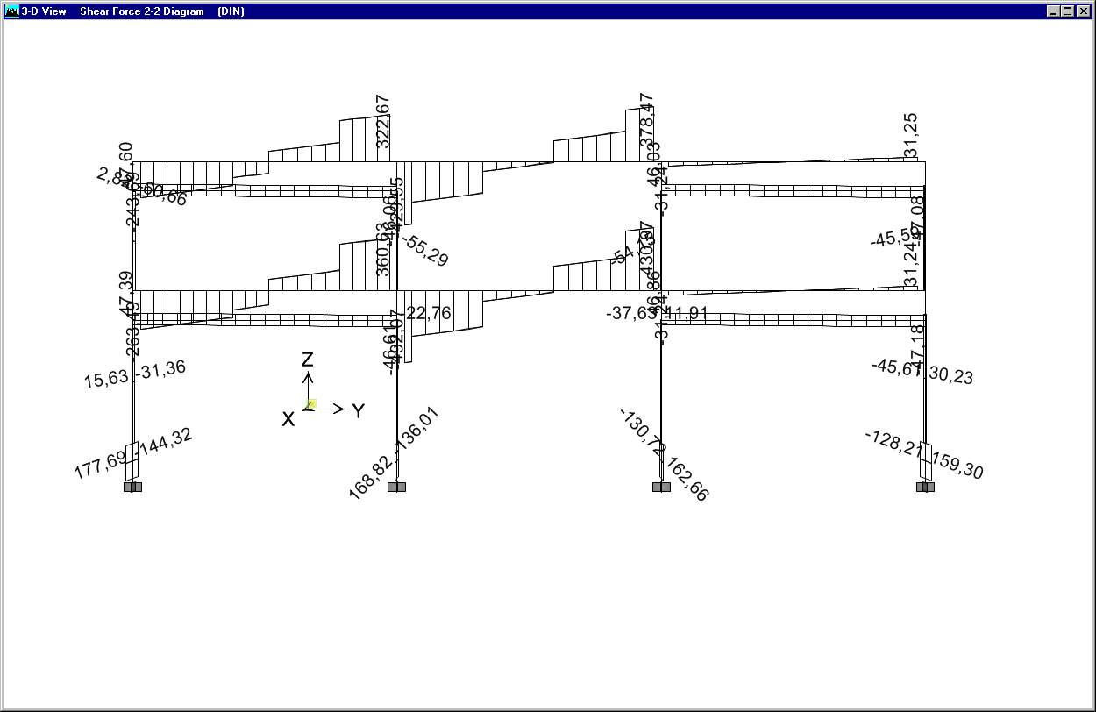
PRESJEK F:

M 3-3
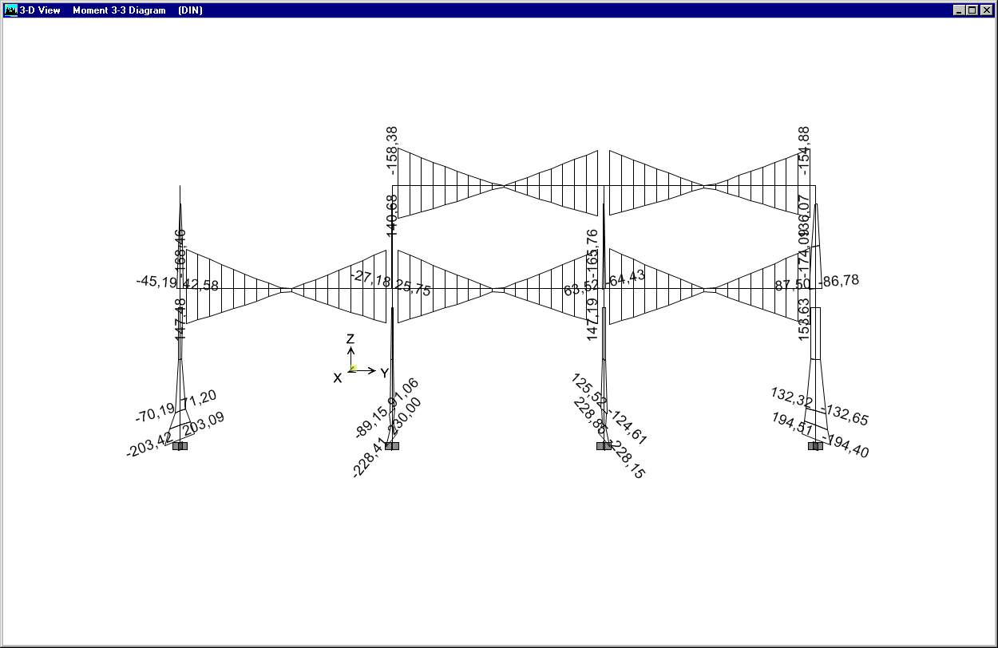
M 2-2
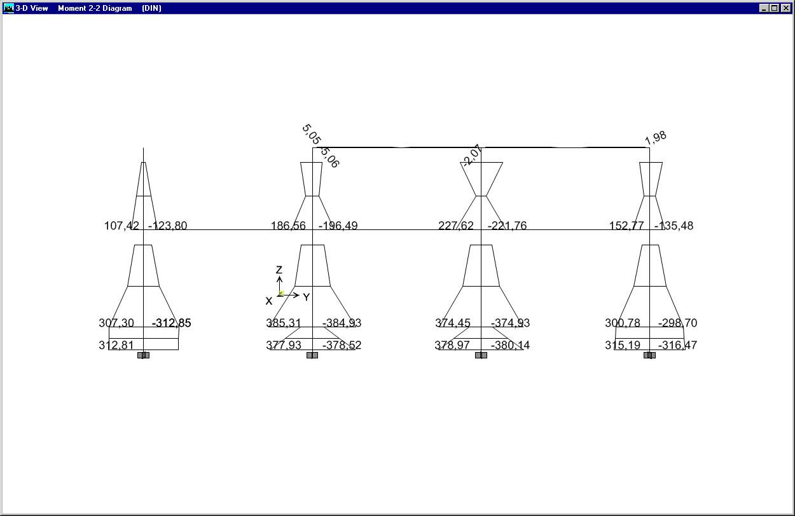
N

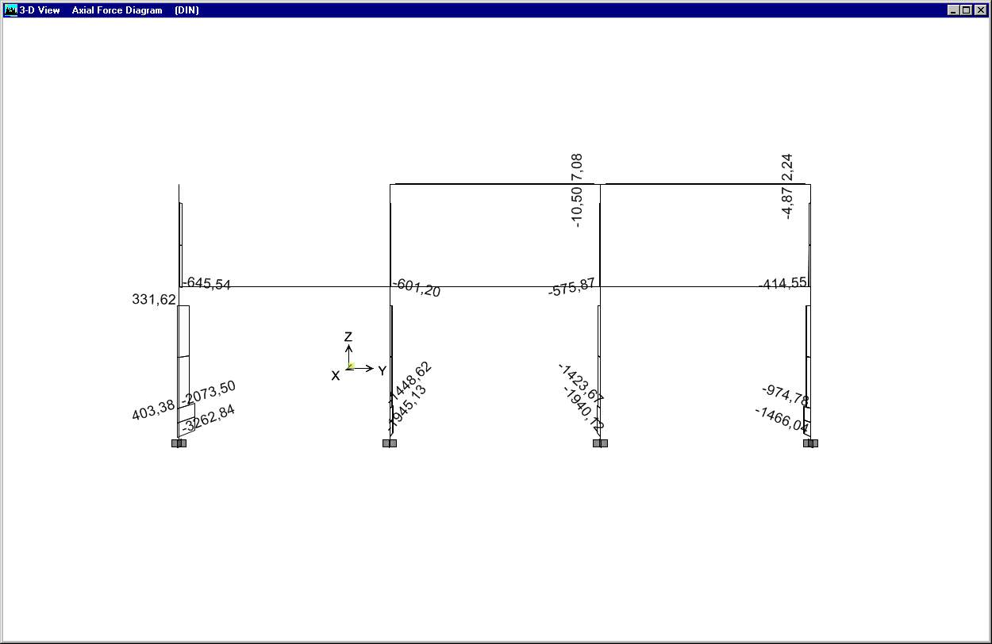

T 3-3
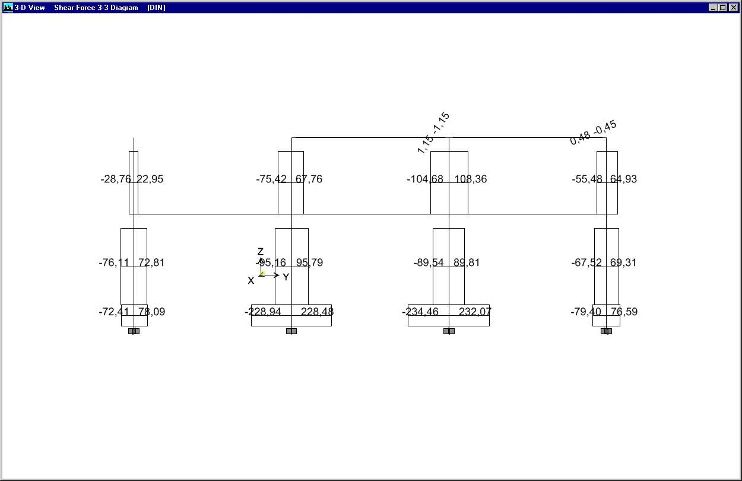

T 2-2
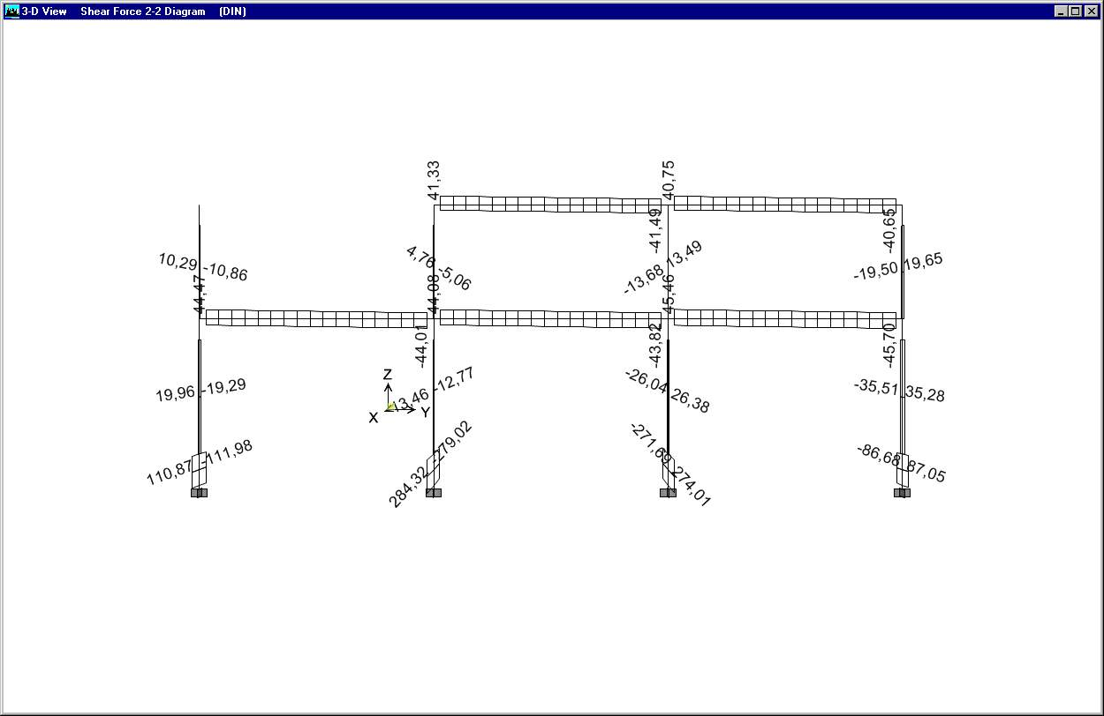

DIMENZIONIRANJE ČELIKA

- iznesene su osnovne postavke proračuna sa nekim općim informacijama

- dimenzionirani su karakteristicni elementi

- dimenzionirani su svi čelični elementi koji će biti ugrađeni u konstrukciju (nekim elementima ciljano je prokoračena nosivost)

M A T E R I A L P R O P E R T Y D A T A

MATERIAL MATERIAL DESIGN MATERIAL MODULUS OF POISSON'S THERMAL SHEAR
NAME TYPE TYPE DIR/PLANE ELASTICITY RATIO COEFF MODULUS

STEEL Iso Steel All 199948000 0,3000 1,1700E-05 76903077

M A T E R I A L P R O P E R T Y M A S S A N D W E I G H T

MATERIAL MASS PER WEIGHT PER
NAME UNIT VOL UNIT VOL

STEEL 7,8271E+00 7,6820E+01

M A T E R I A L D E S I G N D A T A F O R STEEL MATERIALS

MATERIAL STEEL STEEL STEEL
NAME FY FU COST ($)

STEEL 344737,900 448159,300 271447,20

M A T E R I A L D E S I G N D A T A F O R CONCRETE MATERIALS

MATERIAL LIGHTWEIGHT CONCRETE REBAR REBAR LIGHTWT
NAME CONCRETE FC FY FYS REDUC FACT

F R A M E S E C T I O N P R O P E R T Y D A T A

MATERIAL SECTION SHAPE NAME OR NAME CONC CONC
FRAME SECTION NAME NAME IN SECTION DATABASE FILE COL BEAM

TUBO220X110X12.5 STEEL TUBO220X110X12.5
TUBO100X100X5.9 STEEL TUBO100X100X5.9
HE300-A STEEL HE300-A
TUBO160X80X12.5 STEEL TUBO160X80X12.5
TUBO300X150X10 STEEL TUBO300X150X10

F R A M E S E C T I O N P R O P E R T Y D A T A

SECTION FLANGE FLANGE WEB FLANGE FLANGE
FRAME SECTION NAME DEPTH WIDTH TOP THICK TOP THICK WIDTH BOT THICK BOT

TUBO220X110X12.5 0,2200 0,1100 0,0125 0,0125 0,0000 0,0000
TUBO100X100X5.9 0,1000 0,1000 0,0059 0,0059 0,0000 0,0000
HE300-A 0,2900 0,3000 0,0140 0,0085 0,3000 0,0140
TUBO160X80X12.5 0,1600 0,0800 0,0125 0,0125 0,0000 0,0000
TUBO300X150X10 0,3000 0,1500 0,0100 0,0100 0,0000 0,0000

F R A M E S E C T I O N P R O P E R T Y D A T A

SECTION TORSIONAL MOMENTS OF INERTIA SHEAR AREAS
FRAME SECTION NAME AREA CONSTANT I33 I22 A2 A3

TUBO220X110X12.5 0,0076 0,0000 0,0000 0,0000 0,0055 0,0028
TUBO100X100X5.9 0,0022 0,0000 0,0000 0,0000 0,0012 0,0012
HE300-A 0,0113 0,0000 0,0002 0,0001 0,0025 0,0070
TUBO160X80X12.5 0,0054 0,0000 0,0000 0,0000 0,0040 0,0020
TUBO300X150X10 0,0086 0,0001 0,0001 0,0000 0,0060 0,0030

F R A M E S E C T I O N P R O P E R T Y D A T A

SECTION MODULI PLASTIC MODULI RADIUS OF GYRATION
FRAME SECTION NAME S33 S22 Z33 Z22 R33 R22

TUBO220X110X12.5 0,0004 0,0003 0,0005 0,0003 0,0769 0,0435
TUBO100X100X5.9 0,0001 0,0001 0,0001 0,0001 0,0385 0,0385
HE300-A 0,0013 0,0004 0,0014 0,0006 0,1271 0,0747
TUBO160X80X12.5 0,0002 0,0001 0,0003 0,0002 0,0546 0,0304
TUBO300X150X10 0,0007 0,0004 0,0008 0,0005 0,1077 0,0620

L O A D I N G C O M B I N A T I O N S

COMBO CASE SCALE
COMBO TYPE CASE TYPE FACTOR

STAT ADD DEAD Static 1,3500
SLOJEVI Static 1,3500
POKRETNO Static 1,3500
SNIJEG Static 1,3500

DIN ADD DEAD Static 1,0000
SLOJEVI Static 1,0000
POKRETNO Static 0,3000
EC1 Spectra 1,0000
SNIJEG Static 0,3000

C O D E P R E F E R E N C E S

Code: EUROCODE 3-1993

Gamma_M0 : 1,1
Gamma_M1 : 1,1
Psi_vec : 0,8
K_tau : 5,34

B E A M S T E E L S T R E S S C H E C K ELEMENT INFORMATION (EUROCODE 3-1993)

STORY BEAM SECTION FRAMING RLLF L_RATIO L_RATIO K K
LEVEL BAY ID TYPE FACTOR MAJOR MINOR MAJOR MINOR

STORY2 B117 TUBO160X80X1 MOMENT 1,000 0,917 0,250 1,000 1,000
STORY1 B117 TUBO160X80X1 MOMENT 1,000 0,917 0,250 1,000 1,000
STORY2 B124 TUBO160X80X1 MOMENT 1,000 0,917 0,250 1,000 1,000
STORY1 B124 TUBO160X80X1 MOMENT 1,000 0,917 0,250 1,000 1,000
STORY2 B163 HE300-A MOMENT 1,000 0,944 0,944 1,000 1,000
STORY1 B163 HE300-A MOMENT 1,000 0,944 0,944 1,000 1,000
STORY2 B164 HE300-A MOMENT 1,000 0,944 0,944 1,000 1,000
STORY1 B164 HE300-A MOMENT 1,000 0,944 0,944 1,000 1,000
STORY2 B165 HE300-A MOMENT 1,000 0,944 0,944 1,000 1,000
STORY1 B165 HE300-A MOMENT 1,000 0,944 0,944 1,000 1,000
STORY2 B166 HE300-A MOMENT 1,000 0,944 0,944 1,000 1,000
STORY1 B166 HE300-A MOMENT 1,000 0,944 0,944 1,000 1,000
STORY2 B167 HE300-A MOMENT 1,000 0,944 0,944 1,000 1,000
STORY1 B167 HE300-A MOMENT 1,000 0,944 0,944 1,000 1,000
STORY2 B168 HE300-A MOMENT 1,000 0,944 0,944 1,000 1,000
STORY1 B168 HE300-A MOMENT 1,000 0,944 0,944 1,000 1,000
STORY2 B169 HE300-A MOMENT 1,000 0,944 0,944 1,000 1,000
STORY1 B169 HE300-A MOMENT 1,000 0,944 0,944 1,000 1,000
STORY2 B170 HE300-A MOMENT 1,000 0,944 0,944 1,000 1,000
STORY1 B170 HE300-A MOMENT 1,000 0,944 0,944 1,000 1,000
STORY1 B182 HE300-A MOMENT 1,000 0,944 0,944 1,000 1,000
STORY1 B183 HE300-A MOMENT 1,000 0,944 0,944 1,000 1,000
STORY1 B184 HE300-A MOMENT 1,000 0,944 0,944 1,000 1,000
STORY1 B126 HE300-A MOMENT 1,000 1,000 1,000 1,000 1,000
STORY1 B127 HE300-A MOMENT 1,000 1,000 1,000 1,000 1,000
STORY1 B128 HE300-A MOMENT 1,000 1,000 1,000 1,000 1,000
STORY1 B129 HE300-A MOMENT 1,000 1,000 1,000 1,000 1,000
STORY1 B131 HE300-A MOMENT 1,000 1,000 1,000 1,000 1,000
STORY1 B138 HE300-A MOMENT 1,000 1,000 1,000 1,000 1,000
STORY1 B140 HE300-A MOMENT 1,000 1,000 1,000 1,000 1,000
STORY1 B141 HE300-A MOMENT 1,000 1,000 1,000 1,000 1,000
STORY1 B142 HE300-A MOMENT 1,000 1,000 1,000 1,000 1,000
STORY1 B143 HE300-A MOMENT 1,000 1,000 1,000 1,000 1,000
STORY2 B144 HE300-A MOMENT 1,000 1,000 1,000 1,000 1,000
STORY2 B145 HE300-A MOMENT 1,000 1,000 1,000 1,000 1,000
STORY2 B146 HE300-A MOMENT 1,000 1,000 1,000 1,000 1,000
STORY2 B147 HE300-A MOMENT 1,000 1,000 1,000 1,000 1,000
STORY2 B148 HE300-A MOMENT 1,000 1,000 1,000 1,000 1,000
STORY2 B149 HE300-A MOMENT 1,000 1,000 1,000 1,000 1,000
STORY2 B150 HE300-A MOMENT 1,000 1,000 1,000 1,000 1,000
STORY2 B151 HE300-A MOMENT 1,000 1,000 1,000 1,000 1,000
STORY2 B152 HE300-A MOMENT 1,000 1,000 1,000 1,000 1,000
STORY2 B153 HE300-A MOMENT 1,000 1,000 1,000 1,000 1,000
STORY1 B160 HE300-A MOMENT 1,000 0,944 0,944 1,000 1,000

B R A C E S T E E L S T R E S S C H E C K ELEMENT INFORMATION (EUROCODE 3-1993)

STORY BRACE SECTION FRAMING RLLF L_RATIO L_RATIO K K
LEVEL BAY ID TYPE FACTOR MAJOR MINOR MAJOR MINOR

STORY1 D26 TUBO300X150X MOMENT 1,000 2,000 1,000 1,000 1,000
STORY1 D27 TUBO300X150X MOMENT 1,000 2,000 1,000 1,000 1,000
STORY1 D28 TUBO300X150X MOMENT 1,000 2,000 1,000 1,000 1,000
STORY1 D29 TUBO300X150X MOMENT 1,000 2,000 1,000 1,000 1,000
STORY2 D34 TUBO220X110X MOMENT 1,000 2,000 1,000 1,000 1,000
STORY2 D35 TUBO220X110X MOMENT 1,000 2,000 1,000 1,000 1,000
STORY2 D36 TUBO220X110X MOMENT 1,000 1,000 1,000 1,000 1,000
STORY2 D37 TUBO220X110X MOMENT 1,000 1,000 1,000 1,000 1,000
STORY1 D46 TUBO300X150X MOMENT 1,000 2,000 1,000 1,000 1,000
STORY1 D47 TUBO300X150X MOMENT 1,000 2,000 1,000 1,000 1,000
STORY2 D48 TUBO220X110X MOMENT 1,000 2,023 1,000 1,000 1,000
STORY2 D49 TUBO220X110X MOMENT 1,000 1,978 1,000 1,000 1,000
STORY2 D51 TUBO220X110X MOMENT 1,000 1,000 1,000 1,000 1,000
STORY1 D52 TUBO300X150X MOMENT 1,000 2,000 1,000 1,000 1,000
STORY1 D53 TUBO300X150X MOMENT 1,000 2,000 1,000 1,000 1,000
STORY2 D54 TUBO220X110X MOMENT 1,000 1,000 1,000 1,000 1,000
STORY2 D2 TUBO100X100X MOMENT 1,000 1,000 1,000 1,000 1,000
STORY1 D2 TUBO100X100X MOMENT 1,000 1,000 1,000 1,000 1,000
STORY2 D3 TUBO100X100X MOMENT 1,000 1,000 1,000 1,000 1,000
STORY1 D3 TUBO100X100X MOMENT 1,000 1,000 1,000 1,000 1,000
STORY2 D4 TUBO100X100X MOMENT 1,000 1,000 1,000 1,000 1,000
STORY1 D4 TUBO100X100X MOMENT 1,000 1,000 1,000 1,000 1,000
STORY2 D5 TUBO100X100X MOMENT 1,000 1,000 1,000 1,000 1,000
STORY1 D5 TUBO100X100X MOMENT 1,000 1,000 1,000 1,000 1,000
STORY2 D6 TUBO100X100X MOMENT 1,000 1,000 1,000 1,000 1,000
STORY1 D6 TUBO100X100X MOMENT 1,000 1,000 1,000 1,000 1,000
STORY2 D7 TUBO100X100X MOMENT 1,000 1,000 1,000 1,000 1,000
STORY1 D7 TUBO100X100X MOMENT 1,000 1,000 1,000 1,000 1,000
STORY2 D11 TUBO100X100X MOMENT 1,000 1,000 1,000 1,000 1,000
STORY1 D11 TUBO100X100X MOMENT 1,000 1,000 1,000 1,000 1,000
STORY2 D12 TUBO100X100X MOMENT 1,000 1,000 1,000 1,000 1,000
STORY1 D12 TUBO100X100X MOMENT 1,000 1,000 1,000 1,000 1,000
STORY2 D13 TUBO100X100X MOMENT 1,000 1,000 1,000 1,000 1,000
STORY1 D13 TUBO100X100X MOMENT 1,000 1,000 1,000 1,000 1,000
STORY2 D14 TUBO100X100X MOMENT 1,000 1,000 1,000 1,000 1,000
STORY1 D14 TUBO100X100X MOMENT 1,000 1,000 1,000 1,000 1,000
STORY2 D15 TUBO100X100X MOMENT 1,000 1,000 1,000 1,000 1,000
STORY1 D15 TUBO100X100X MOMENT 1,000 1,000 1,000 1,000 1,000
STORY2 D16 TUBO100X100X MOMENT 1,000 1,000 1,000 1,000 1,000
STORY1 D16 TUBO100X100X MOMENT 1,000 1,000 1,000 1,000 1,000
STORY2 D17 TUBO100X100X MOMENT 1,000 1,000 1,000 1,000 1,000
STORY1 D17 TUBO100X100X MOMENT 1,000 1,000 1,000 1,000 1,000
STORY2 D18 TUBO100X100X MOMENT 1,000 1,000 1,000 1,000 1,000
STORY1 D18 TUBO100X100X MOMENT 1,000 1,000 1,000 1,000 1,000
STORY2 D19 TUBO100X100X MOMENT 1,000 1,000 1,000 1,000 1,000
STORY1 D19 TUBO100X100X MOMENT 1,000 1,000 1,000 1,000 1,000
STORY2 D20 TUBO100X100X MOMENT 1,000 1,000 1,000 1,000 1,000
STORY1 D20 TUBO100X100X MOMENT 1,000 1,000 1,000 1,000 1,000

B E A M S T E E L S T R E S S CHECK OUTPUT (EUROCODE 3-1993)

STORY BEAM SECTION /----------MOMENT INTERACTION CHECK---------//----SHEAR22---//----SHEAR33---/
LEVEL BAY ID COMBO RATIO = AXL + B33 + B22 COMBO RATIO COMBO RATIO

STORY2 B117 TUBO160X80X12.5 DIN 0,000 STAT 0,004
DIN(C) 0,986 = 0,972 + 0,003 + 0,011
DIN(T) 0,154 = 0,139 + 0,004 + 0,010
STORY1 B117 TUBO160X80X12.5 DIN 0,000 STAT 0,004
DIN(C) 1,238 = 1,222 + 0,002 + 0,014
DIN(T) 0,201 = 0,186 + 0,002 + 0,012
STORY2 B124 TUBO160X80X12.5 DIN 0,000 STAT 0,004
DIN(C) 0,986 = 0,972 + 0,003 + 0,011
DIN(T) 0,154 = 0,139 + 0,004 + 0,010
STORY1 B124 TUBO160X80X12.5 DIN 0,000 STAT 0,004
DIN(C) 1,238 = 1,222 + 0,002 + 0,014
DIN(T) 0,201 = 0,186 + 0,002 + 0,012
STORY2 B163 HE300-A DIN 0,090 DIN 0,000
DIN(C) 0,609 = 0,005 + 0,588 + 0,015
STORY1 B163 HE300-A DIN 0,104 DIN 0,000
DIN(T) 0,685 = 0,000 + 0,685 + 0,000
STORY2 B164 HE300-A DIN 0,092 DIN 0,001
DIN(C) 0,637 = 0,009 + 0,601 + 0,027
STORY1 B164 HE300-A DIN 0,099 DIN 0,000
DIN(T) 0,650 = 0,000 + 0,650 + 0,000
STORY2 B165 HE300-A DIN 0,091 DIN 0,000
DIN(C) 0,617 = 0,004 + 0,597 + 0,015
STORY1 B165 HE300-A DIN 0,102 DIN 0,000
DIN(T) 0,675 = 0,000 + 0,675 + 0,000
STORY2 B166 HE300-A DIN 0,093 DIN 0,001
DIN(C) 0,657 = 0,009 + 0,609 + 0,039
STORY1 B166 HE300-A DIN 0,099 DIN 0,000
DIN(T) 0,645 = 0,000 + 0,645 + 0,000
STORY2 B167 HE300-A DIN 0,091 DIN 0,000
DIN(C) 0,617 = 0,004 + 0,597 + 0,015
STORY1 B167 HE300-A DIN 0,102 DIN 0,000
DIN(T) 0,675 = 0,000 + 0,675 + 0,000
STORY2 B168 HE300-A DIN 0,093 DIN 0,001
DIN(C) 0,657 = 0,009 + 0,609 + 0,039
STORY1 B168 HE300-A DIN 0,099 DIN 0,000
DIN(T) 0,645 = 0,000 + 0,645 + 0,000
STORY2 B169 HE300-A DIN 0,090 DIN 0,000
DIN(C) 0,609 = 0,005 + 0,588 + 0,015
STORY1 B169 HE300-A DIN 0,104 DIN 0,000
DIN(T) 0,685 = 0,000 + 0,685 + 0,000
STORY2 B170 HE300-A DIN 0,092 DIN 0,001
DIN(C) 0,637 = 0,009 + 0,601 + 0,027
STORY1 B170 HE300-A DIN 0,099 DIN 0,000
DIN(T) 0,650 = 0,000 + 0,650 + 0,000
STORY1 B182 HE300-A DIN 0,100 DIN 0,000
DIN(T) 0,653 = 0,000 + 0,653 + 0,000
STORY1 B183 HE300-A DIN 0,100 DIN 0,000
DIN(T) 0,653 = 0,000 + 0,653 + 0,000
STORY1 B184 HE300-A DIN 0,101 DIN 0,000
DIN(T) 0,662 = 0,000 + 0,662 + 0,000
STORY1 B126 HE300-A DIN 0,107 DIN 0,000
DIN(C) 0,830 = 0,036 + 0,780 + 0,014
STAT(T) 0,065 = 0,002 + 0,062 + 0,001
STORY1 B127 HE300-A DIN 0,104 DIN 0,000
DIN(T) 0,755 = 0,000 + 0,753 + 0,002
STORY1 B128 HE300-A DIN 0,107 DIN 0,000
DIN(C) 0,820 = 0,034 + 0,781 + 0,005
STAT(T) 0,068 = 0,002 + 0,064 + 0,002
STORY1 B129 HE300-A DIN 0,106 DIN 0,000
DIN(C) 0,790 = 0,024 + 0,763 + 0,002
STORY1 B131 HE300-A DIN 0,106 DIN 0,000
DIN(T) 0,771 = 0,001 + 0,766 + 0,004
STORY1 B138 HE300-A DIN 0,106 DIN 0,000
DIN(C) 0,790 = 0,024 + 0,763 + 0,002
STORY1 B140 HE300-A DIN 0,106 DIN 0,000
DIN(T) 0,771 = 0,001 + 0,766 + 0,004
STORY1 B141 HE300-A DIN 0,107 DIN 0,000
DIN(C) 0,830 = 0,036 + 0,780 + 0,014
STAT(T) 0,065 = 0,002 + 0,062 + 0,001
STORY1 B142 HE300-A DIN 0,104 DIN 0,000
DIN(T) 0,755 = 0,000 + 0,754 + 0,002
STORY1 B143 HE300-A DIN 0,107 DIN 0,000
DIN(C) 0,820 = 0,034 + 0,781 + 0,005
STAT(T) 0,068 = 0,002 + 0,064 + 0,002
STORY2 B144 HE300-A DIN 0,097 DIN 0,000
DIN(C) 0,732 = 0,024 + 0,696 + 0,012
STAT(T) 0,065 = 0,002 + 0,062 + 0,001
STORY2 B145 HE300-A DIN 0,095 DIN 0,000
DIN(C) 0,705 = 0,017 + 0,675 + 0,012
STAT(T) 0,066 = 0,001 + 0,064 + 0,000
STORY2 B146 HE300-A DIN 0,098 DIN 0,000
DIN(C) 0,753 = 0,034 + 0,699 + 0,019
STAT(T) 0,069 = 0,002 + 0,066 + 0,001
STORY2 B147 HE300-A DIN 0,106 DIN 0,000
DIN(C) 0,788 = 0,023 + 0,758 + 0,006
STORY2 B148 HE300-A DIN 0,107 DIN 0,000
DIN(T) 0,779 = 0,001 + 0,768 + 0,011
STORY2 B149 HE300-A DIN 0,106 DIN 0,000
DIN(C) 0,788 = 0,023 + 0,758 + 0,006
STORY2 B150 HE300-A DIN 0,107 DIN 0,000
DIN(T) 0,779 = 0,001 + 0,768 + 0,011
STORY2 B151 HE300-A DIN 0,097 DIN 0,000
DIN(C) 0,732 = 0,024 + 0,696 + 0,012
STAT(T) 0,065 = 0,002 + 0,062 + 0,001
STORY2 B152 HE300-A DIN 0,095 DIN 0,000
DIN(C) 0,705 = 0,017 + 0,675 + 0,012
STAT(T) 0,066 = 0,001 + 0,064 + 0,000
STORY2 B153 HE300-A DIN 0,098 DIN 0,000
DIN(C) 0,753 = 0,034 + 0,699 + 0,019
STAT(T) 0,069 = 0,002 + 0,066 + 0,001
STORY1 B160 HE300-A DIN 0,101 DIN 0,000
DIN(T) 0,662 = 0,000 + 0,662 + 0,000

B R A C E S T E E L S T R E S S CHECK OUTPUT (EUROCODE 3-1993)

STORY BRACE SECTION /----------MOMENT INTERACTION CHECK---------//----SHEAR22---//----SHEAR33---/
LEVEL BAY ID COMBO RATIO = AXL + B33 + B22 COMBO RATIO COMBO RATIO

STORY1 D26 TUBO300X150X10 DIN 0,001 STAT 0,009
DIN(C) 1,123 = 1,067 + 0,018 + 0,038
STORY1 D27 TUBO300X150X10 DIN 0,001 STAT 0,009
DIN(C) 1,122 = 1,057 + 0,022 + 0,043
STORY1 D28 TUBO300X150X10 DIN 0,001 STAT 0,009
DIN(C) 1,094 = 1,038 + 0,019 + 0,038
STORY1 D29 TUBO300X150X10 DIN 0,001 STAT 0,009
DIN(C) 1,088 = 1,028 + 0,018 + 0,042
STORY2 D34 TUBO220X110X12.5 DIN 0,000 STAT 0,009
DIN(C) 0,973 = 0,902 + 0,022 + 0,050
STORY2 D35 TUBO220X110X12.5 DIN 0,001 STAT 0,009
DIN(C) 0,954 = 0,881 + 0,022 + 0,051
STORY2 D36 TUBO220X110X12.5 DIN 0,000 STAT 0,009
DIN(C) 0,808 = 0,741 + 0,016 + 0,050
STORY2 D37 TUBO220X110X12.5 DIN 0,001 STAT 0,009
DIN(C) 0,793 = 0,725 + 0,016 + 0,052
STORY1 D46 TUBO300X150X10 DIN 0,001 STAT 0,009
DIN(C) 1,129 = 1,067 + 0,024 + 0,038
STORY1 D47 TUBO300X150X10 DIN 0,001 STAT 0,009
DIN(C) 1,118 = 1,057 + 0,019 + 0,043
STORY2 D48 TUBO220X110X12.5 DIN 0,000 STAT 0,009
DIN(C) 0,964 = 0,891 + 0,023 + 0,050
STORY2 D49 TUBO220X110X12.5 DIN 0,000 STAT 0,009
DIN(C) 0,963 = 0,890 + 0,021 + 0,051
STORY2 D51 TUBO220X110X12.5 DIN 0,001 STAT 0,009
DIN(C) 0,780 = 0,711 + 0,016 + 0,052
STORY1 D52 TUBO300X150X10 DIN 0,001 STAT 0,009
DIN(C) 1,094 = 1,038 + 0,018 + 0,038
STORY1 D53 TUBO300X150X10 DIN 0,001 STAT 0,009
DIN(C) 1,086 = 1,028 + 0,016 + 0,042
STORY2 D54 TUBO220X110X12.5 DIN 0,000 STAT 0,009
DIN(C) 0,822 = 0,755 + 0,016 + 0,051
STORY2 D2 TUBO100X100X5.9 STAT 0,002 DIN 0,002
DIN(T) 0,366 = 0,363 + 0,003 + 0,000
STORY1 D2 TUBO100X100X5.9 STAT 0,002 DIN 0,004
DIN(T) 0,486 = 0,483 + 0,003 + 0,000
STORY2 D3 TUBO100X100X5.9 STAT 0,002 DIN 0,002
DIN(C) 0,394 = 0,390 + 0,004 + 0,000
STORY1 D3 TUBO100X100X5.9 STAT 0,002 DIN 0,004
DIN(C) 0,524 = 0,520 + 0,004 + 0,000
STORY2 D4 TUBO100X100X5.9 STAT 0,001 DIN 0,000
DIN(C) 0,223 = 0,220 + 0,003 + 0,000
STORY1 D4 TUBO100X100X5.9 STAT 0,001 DIN 0,000
DIN(C) 0,277 = 0,273 + 0,003 + 0,000
STORY2 D5 TUBO100X100X5.9 STAT 0,001 DIN 0,000
DIN(C) 0,217 = 0,213 + 0,003 + 0,000
STAT(T) 0,011 = 0,007 + 0,004 + 0,000
STORY1 D5 TUBO100X100X5.9 STAT 0,001 DIN 0,000
DIN(C) 0,267 = 0,264 + 0,003 + 0,000
STAT(T) 0,014 = 0,010 + 0,004 + 0,000
STORY2 D6 TUBO100X100X5.9 STAT 0,002 DIN 0,003
DIN(C) 0,407 = 0,403 + 0,004 + 0,000
STORY1 D6 TUBO100X100X5.9 STAT 0,002 DIN 0,005
DIN(C) 0,535 = 0,531 + 0,004 + 0,000
STORY2 D7 TUBO100X100X5.9 STAT 0,002 DIN 0,002
DIN(T) 0,379 = 0,376 + 0,003 + 0,000
STORY1 D7 TUBO100X100X5.9 STAT 0,002 DIN 0,004
DIN(T) 0,496 = 0,493 + 0,003 + 0,000
STORY2 D11 TUBO100X100X5.9 STAT 0,002 DIN 0,002
DIN(T) 0,366 = 0,363 + 0,003 + 0,000
STORY1 D11 TUBO100X100X5.9 STAT 0,002 DIN 0,004
DIN(T) 0,486 = 0,483 + 0,003 + 0,000
STORY2 D12 TUBO100X100X5.9 STAT 0,002 DIN 0,002
DIN(T) 0,379 = 0,376 + 0,003 + 0,000
STORY1 D12 TUBO100X100X5.9 STAT 0,002 DIN 0,004
DIN(T) 0,496 = 0,493 + 0,003 + 0,000
STORY2 D13 TUBO100X100X5.9 STAT 0,002 DIN 0,003
DIN(C) 0,407 = 0,403 + 0,004 + 0,000
STORY1 D13 TUBO100X100X5.9 STAT 0,002 DIN 0,005
DIN(C) 0,535 = 0,531 + 0,004 + 0,000
STORY2 D14 TUBO100X100X5.9 STAT 0,001 DIN 0,000
DIN(C) 0,217 = 0,213 + 0,003 + 0,000
STAT(T) 0,011 = 0,007 + 0,004 + 0,000
STORY1 D14 TUBO100X100X5.9 STAT 0,001 DIN 0,000
DIN(C) 0,267 = 0,264 + 0,003 + 0,000
STAT(T) 0,014 = 0,010 + 0,004 + 0,000
STORY2 D15 TUBO100X100X5.9 STAT 0,001 DIN 0,000
DIN(C) 0,223 = 0,220 + 0,003 + 0,000
STORY1 D15 TUBO100X100X5.9 STAT 0,001 DIN 0,000
DIN(C) 0,277 = 0,273 + 0,003 + 0,000
STORY2 D16 TUBO100X100X5.9 STAT 0,002 DIN 0,002
DIN(C) 0,394 = 0,390 + 0,004 + 0,000
STORY1 D16 TUBO100X100X5.9 STAT 0,002 DIN 0,004
DIN(C) 0,524 = 0,520 + 0,004 + 0,000
STORY2 D17 TUBO100X100X5.9 DIN 0,002 DIN 0,003
DIN(C) 0,527 = 0,523 + 0,004 + 0,000
STORY1 D17 TUBO100X100X5.9 DIN 0,003 DIN 0,006
DIN(C) 0,603 = 0,599 + 0,004 + 0,000
STORY2 D18 TUBO100X100X5.9 DIN 0,002 DIN 0,003
DIN(C) 0,527 = 0,523 + 0,004 + 0,000
STORY1 D18 TUBO100X100X5.9 DIN 0,003 DIN 0,005
DIN(C) 0,587 = 0,583 + 0,004 + 0,000
STORY2 D19 TUBO100X100X5.9 DIN 0,002 DIN 0,003
DIN(C) 0,527 = 0,523 + 0,004 + 0,000
STORY1 D19 TUBO100X100X5.9 DIN 0,003 DIN 0,005
DIN(C) 0,587 = 0,583 + 0,004 + 0,000
STORY2 D20 TUBO100X100X5.9 DIN 0,002 DIN 0,003
DIN(C) 0,527 = 0,523 + 0,004 + 0,000
STORY1 D20 TUBO100X100X5.9 DIN 0,003 DIN 0,006
DIN(C) 0,603 = 0,599 + 0,004 + 0,000

DIMENZIONIRANJE BETONA

- iznesene su osnovne postavke proračuna sa nekim općim informacijama

- sile i dimenzioniranje svakog elementa posebno se nalazi u datoteki concrete.txt

C O D E P R E F E R E N C E S

Code: EUROCODE 2-1992

Gamma_concrete : 1,5
Gamma_steel : 1,15
Alpha : 0,8
Nu : 1/100

M A T E R I A L P R O P E R T Y D A T A

MATERIAL MATERIAL DESIGN MATERIAL MODULUS OF POISSON'S THERMAL SHEAR
NAME TYPE TYPE DIR/PLANE ELASTICITY RATIO COEFF MODULUS

CONC Iso Concrete All 24821130 0,2000 9,9000E-06 10342138

M A T E R I A L P R O P E R T Y M A S S A N D W E I G H T

MATERIAL MASS PER WEIGHT PER
NAME UNIT VOL UNIT VOL

CONC 2,4007E+00 2,3562E+01

M A T E R I A L D E S I G N D A T A F O R C O N C R E T E M A T E R I A L S

MATERIAL LIGHTWEIGHT CONCRETE REBAR REBAR LIGHTWT
NAME CONCRETE FC FY FYS REDUC FACT

CONC No 27579,030 413685,500 413685,500 N/A

C O N C R E T E C O L U M N P R O P E R T Y D A T A

SECTION MAT COLUMN COLUMN REBAR CONCRETE BAR
LABEL LABEL DEPTH WIDTH PATTERN COVER AREA

STUP CONC 0,500 0,500 Section type is SD Section.

C O N C R E T E B E A M P R O P E R T Y D A T A

SECTION MAT BEAM BEAM TOP BOTTOM REBAR REBAR REBAR REBAR
LABEL LABEL DEPTH WIDTH COVER COVER AT-1 AT-2 AB-1 AB-2

GL-GR CONC 0,800 0,400 8,000E-02 8,000E-02 0,000 0,000 0,000 0,000
PI-1 CONC 0,400 2,250 1,520E-02 1,520E-02 0,000 0,000 0,000 0,000
PI-SREDN CONC 0,800 2,430 1,524E-02 1,524E-02 0,000 0,000 0,000 0,000
PI-2 CONC 0,400 2,200 4,000E-02 4,000E-02 0,000 0,000 0,000 0,000
POPRECNE CONC 0,600 0,500 6,000E-02 6,000E-02 0,000 0,000 0,000 0,000
POPRECNI CONC 1,000 0,550 0,100 0,100 0,000 0,000 0,000 0,000

