USPOREDBA SADAŠNJEG STANJA I SANACIJE

POTREBNA ARMATURA U STUPOVIMA

SADAŠNJE STANJE :

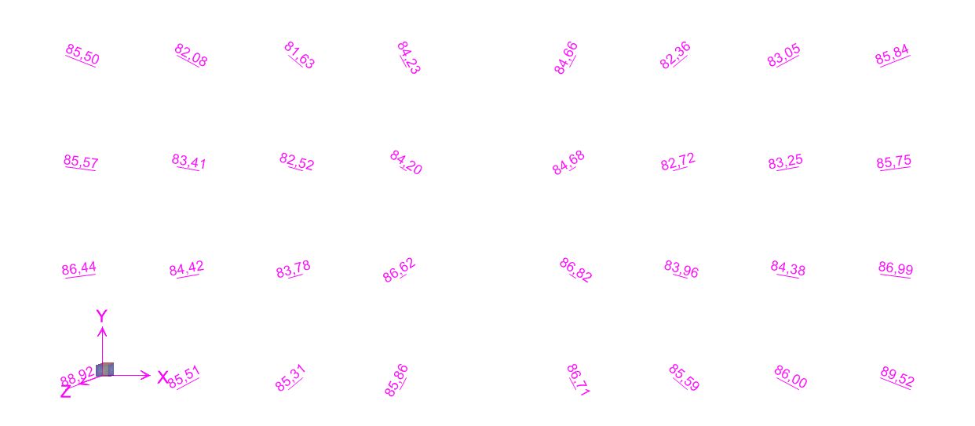

SANACIJA:



VLASTITE FREKVENCIJE I PERIODI

SADAŠNJE STANJE :

MODE PERIOD FREQUENCY CIRCULAR FREQ
NUMBER (TIME) (CYCLES/TIME) (RADIANS/TIME)

Mode 1 3,40078 0,29405 1,84757
Mode 2 3,39654 0,29442 1,84988
Mode 3 2,65611 0,37649 2,36556
Mode 4 0,55409 1,80477 11,33973
Mode 5 0,54153 1,84661 11,60262
Mode 6 0,47150 2,12088 13,32591

SANACIJA:

MODE PERIOD FREQUENCY CIRCULAR FREQ
NUMBER (TIME) (CYCLES/TIME) (RADIANS/TIME)

Mode 1 1,62983 0,61356 3,85512
Mode 2 1,34941 0,74107 4,65625
Mode 3 0,65459 1,52768 9,59868
Mode 4 0,42928 2,32951 14,63673
Mode 5 0,38486 2,59834 16,32583
Mode 6 0,37543 2,66362 16,73599

POMACI

NUMERIRANJE TOČAKA
